125.1

#include <stdio.h>

int main()

{

int numYrs;

float rate;

printf("Enter the year ");

scanf("%d",&numYrs);

if((numYrs<=5)&&(numYrs>0))

{rate=5.4;

printf("rate=%.1f",rate);}

else if(numYrs>5)

{rate=7.5;

printf("rate=%.1f",rate);}

else

printf("\nError");

return 0;

}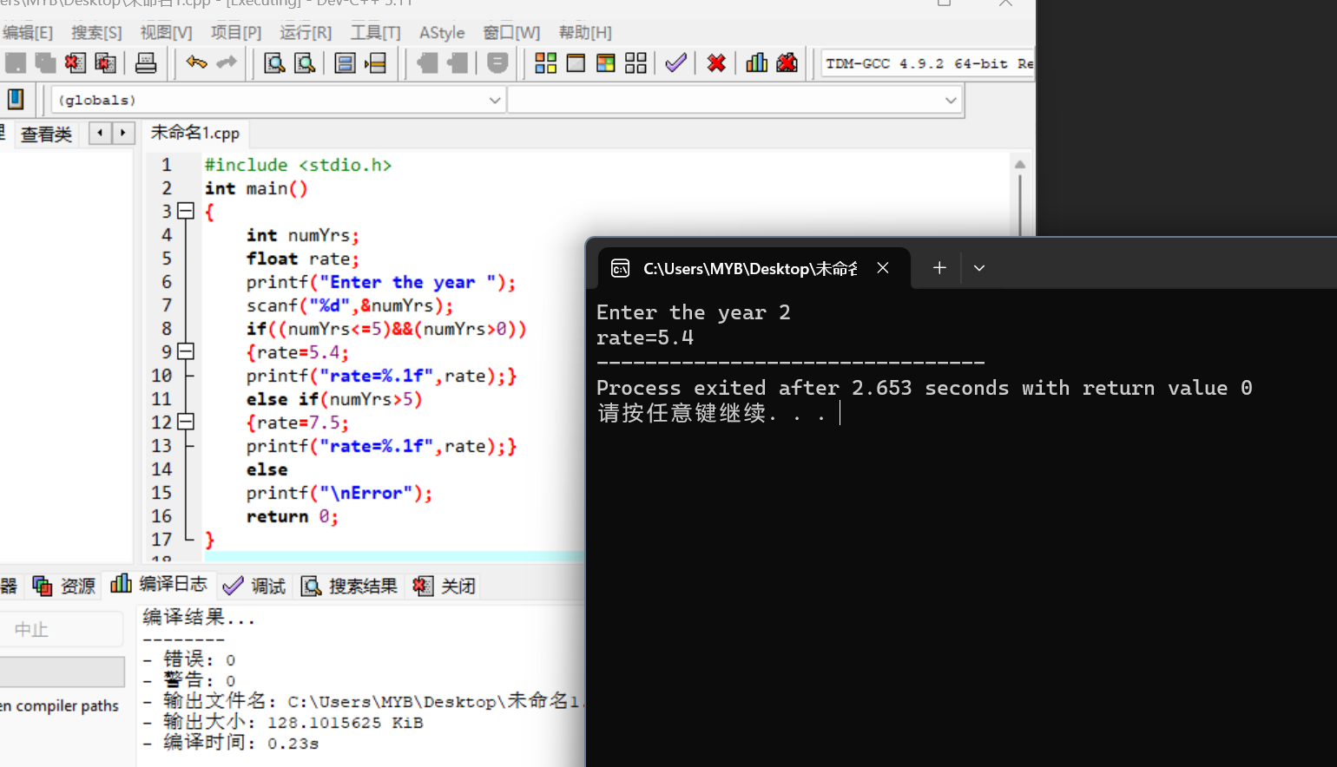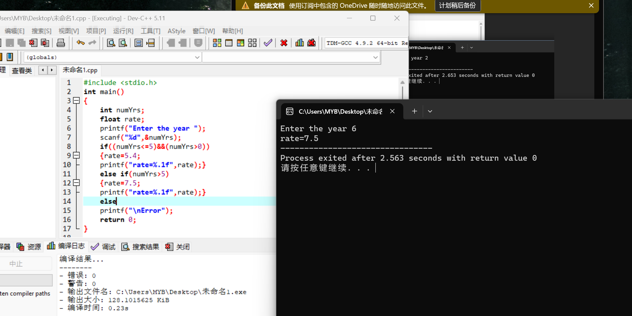

125.4

#include <stdio.h>

int main()

{

char status;

int pay;

printf("Enter a value:'s' is senior and others are all junior ");

scanf("%c",&status);

if(status=='s')

printf("\nYou are paid $800 a week");

else

printf("\nYou are paid $375 a week");

return 0;

}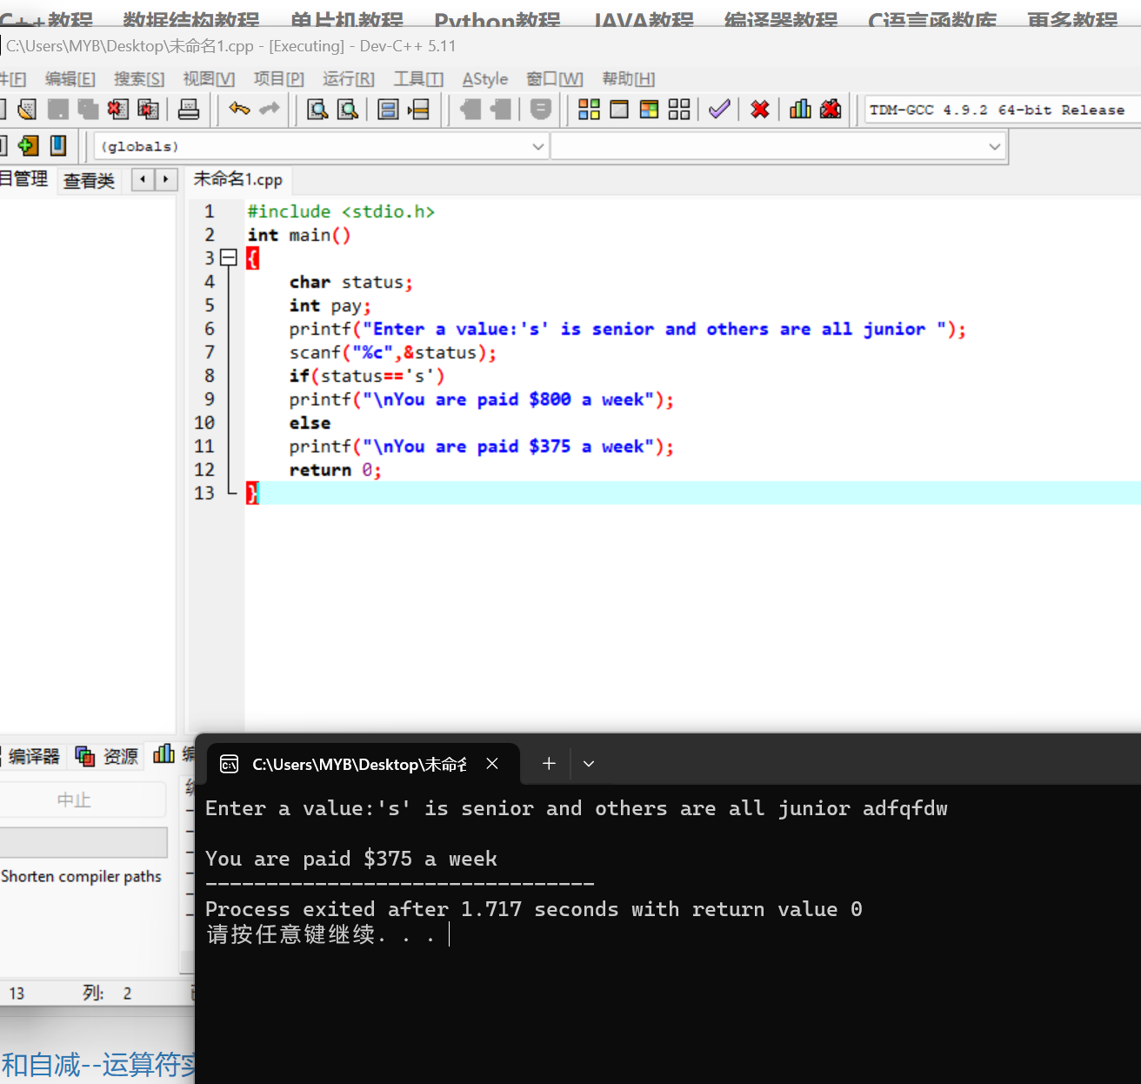

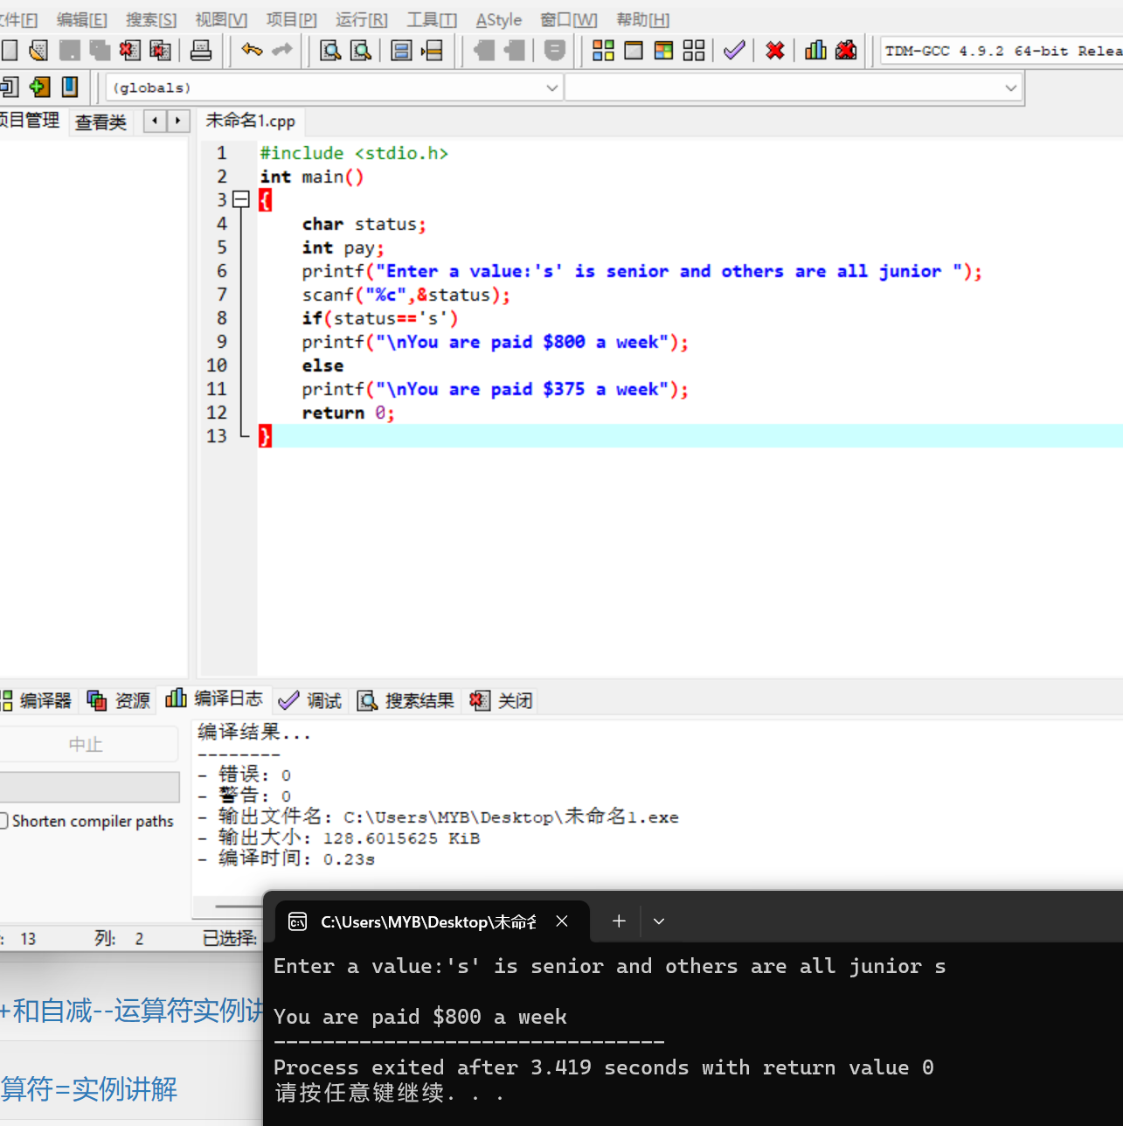

126.6

#include <stdio.h>

#include <math.h>

int main()

{

float s,a,b,c,area;

printf("Enter the sides of triangle(a,b,c):");

scanf("%f,%f,%f",&a,&b,&c);

s=(a+b+c)/2;

if(s\*(s-a)\*(s-b)\*(s-c)<=0)

printf("\nThree sides entered do not represent the sides of a triangle");

else

{area=sqrt(s\*(s-a)\*(s-b)\*(s-c));

printf("area=%f",area);}

return 0;

}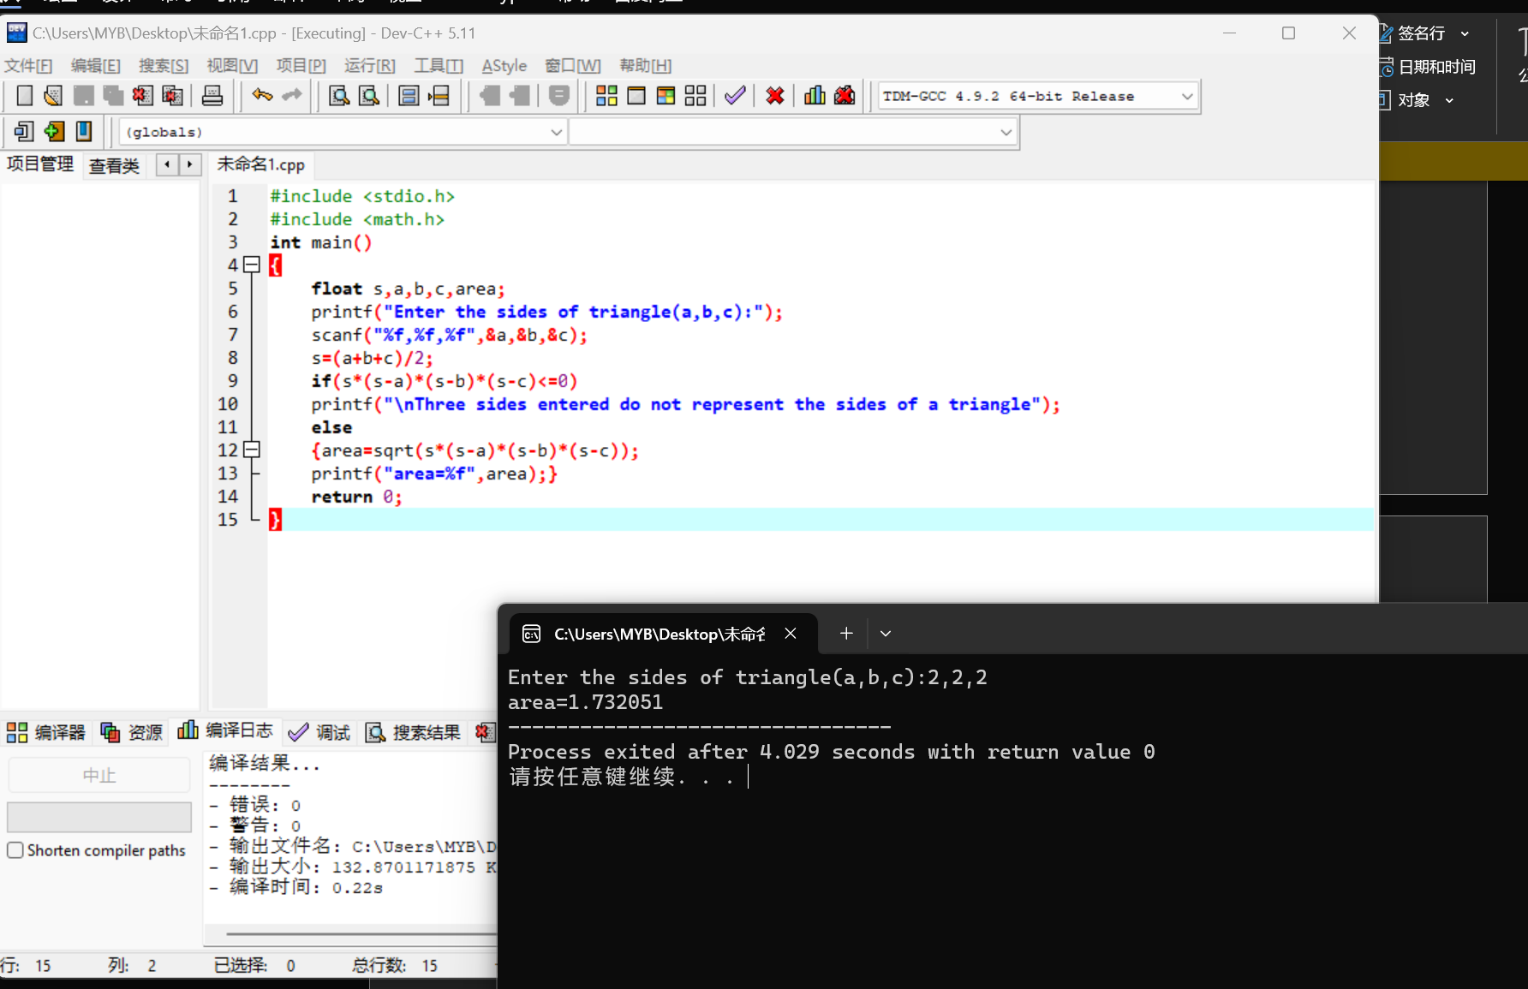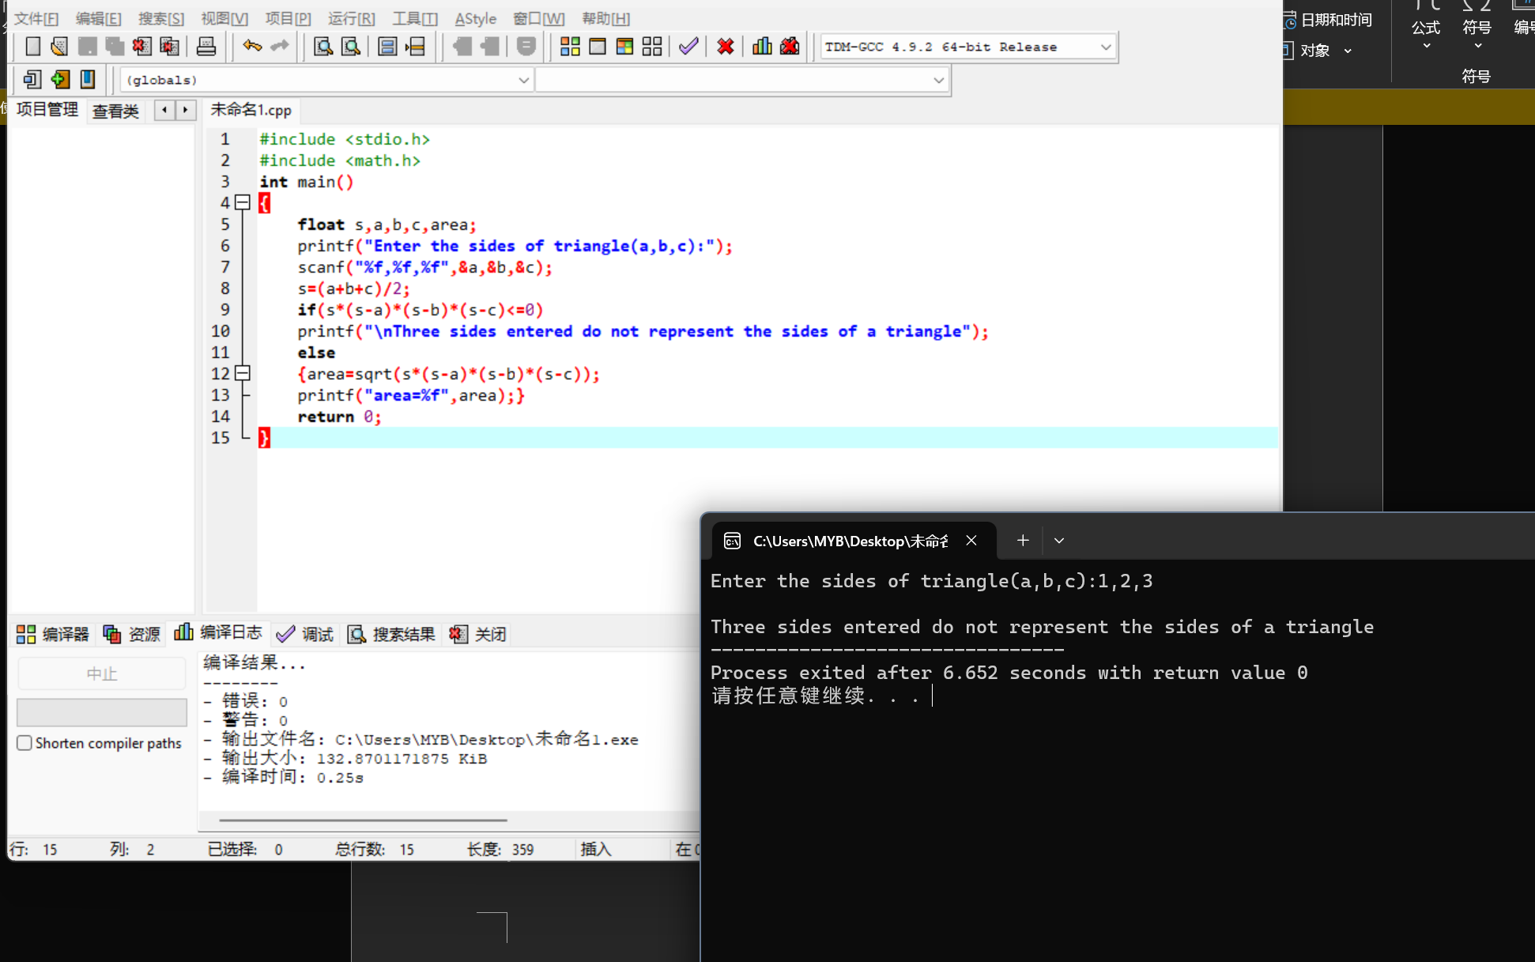

126.7

#include <stdio.h>

int main()

{

char c;

printf("Enter a character:");

scanf("%c",&c);

if('a'<=c&&c<='z')

printf("\nThe character just entered is a lowercase letter.");

else

printf("\nThe character just entered is not a lowercase letter.");

return 0;

}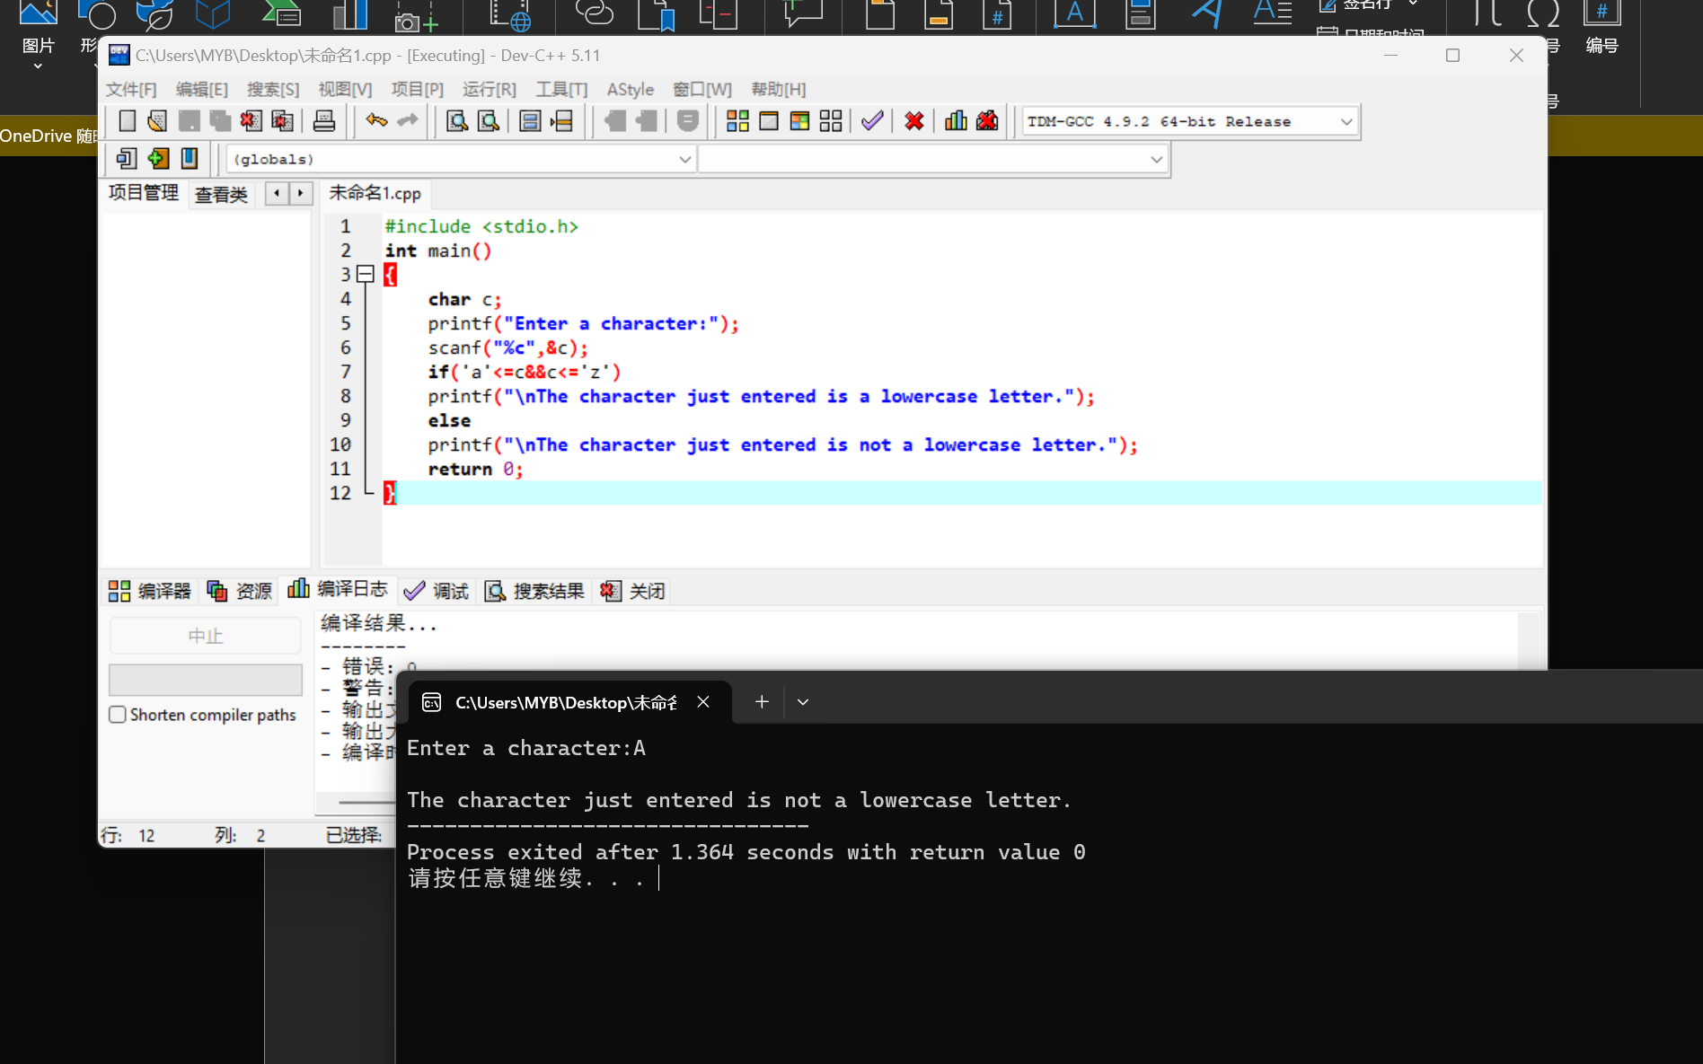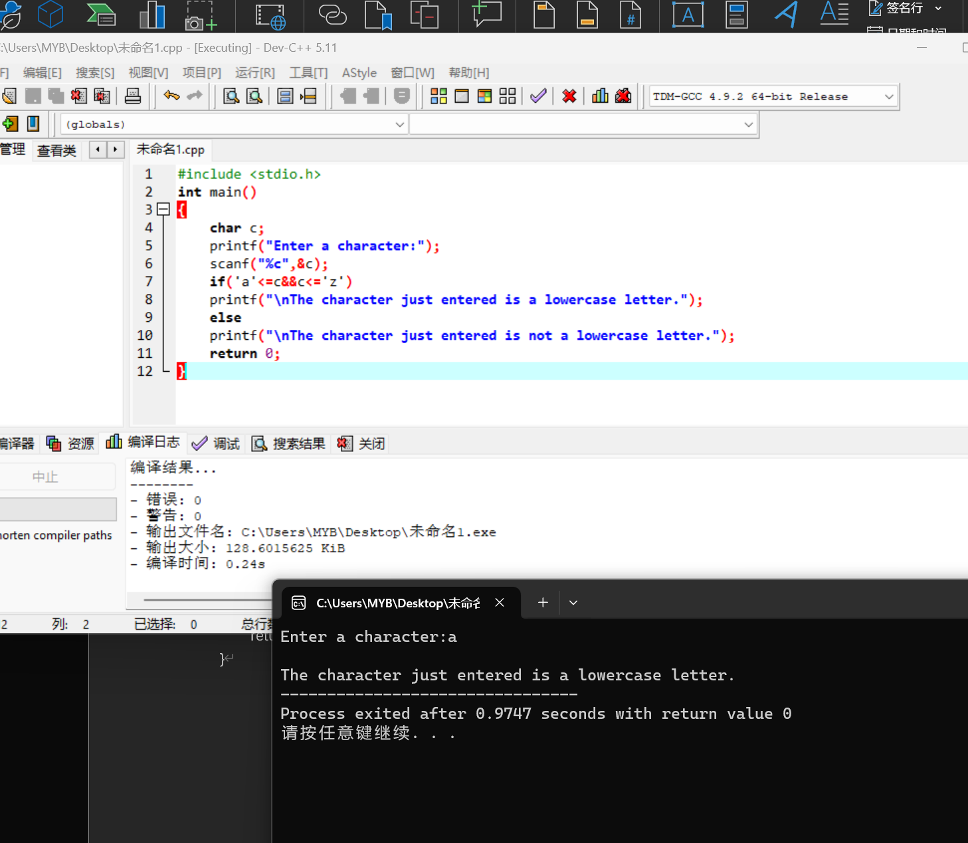

b.

#include <stdio.h>

int main()

{

char c;

printf("Enter a character:");

scanf("%c",&c);

if('A'<=c&&c<='Z')

printf("\nThe character just entered is a uppercase letter.");

else

printf("\nThe character just entered is not a uppercase letter.");

return 0;

}

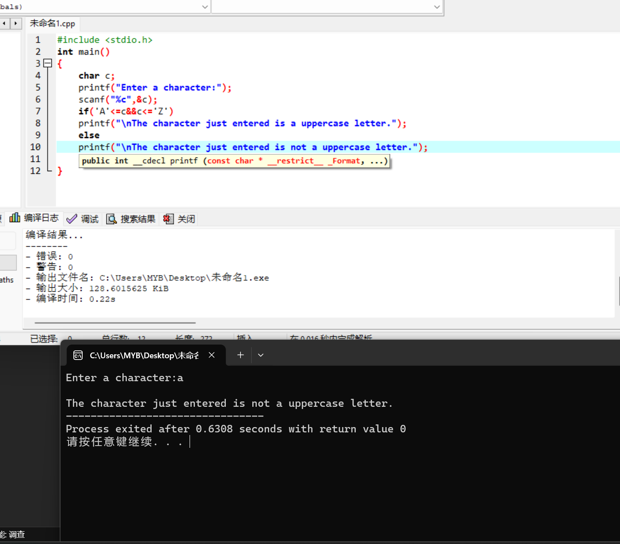 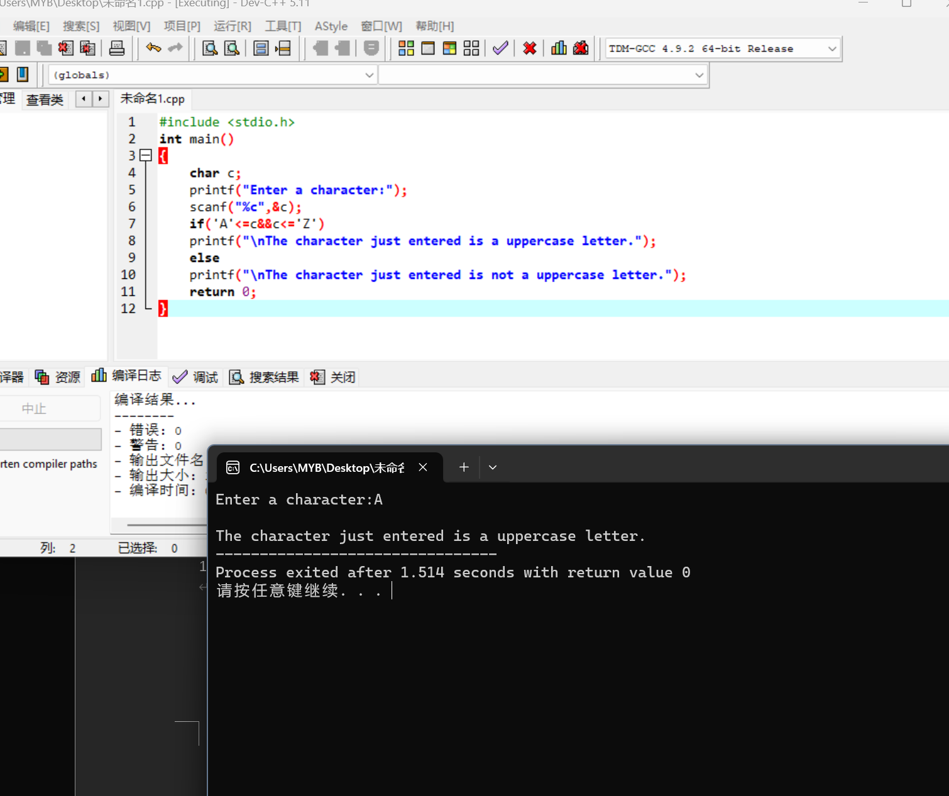

126.8

#include <stdio.h>

int main()

{

char c;

int position;

printf("Enter a character:");

scanf("%c",&c);

if('a'<=c&&c<='z')

{position=c-'a'+1;

printf("\nThe position is:%d",position);}

else

printf("\nThe character just entered is not a lowercase letter.");

return 0;

}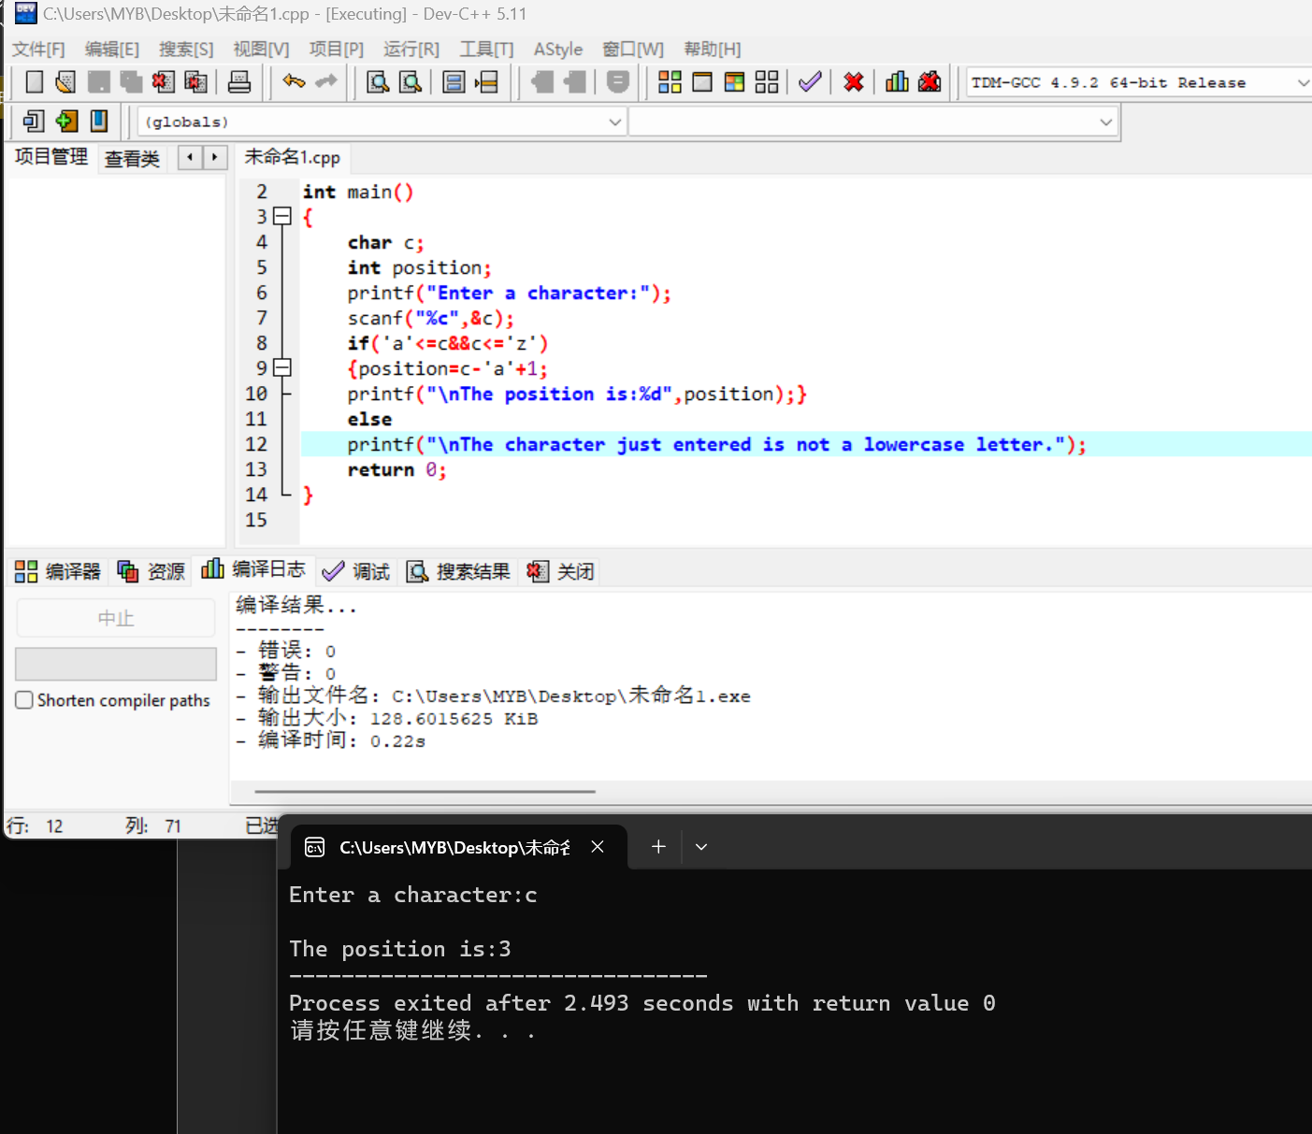

b.

#include <stdio.h>

int main()

{

char c;

int position;

printf("Enter a character:");

scanf("%c",&c);

if('A'<=c&&c<='Z')

{position=c-'A'+1;

printf("\nThe position is:%d",position);}

else

printf("\nThe character just entered is not a uppercase letter.");

return 0;

}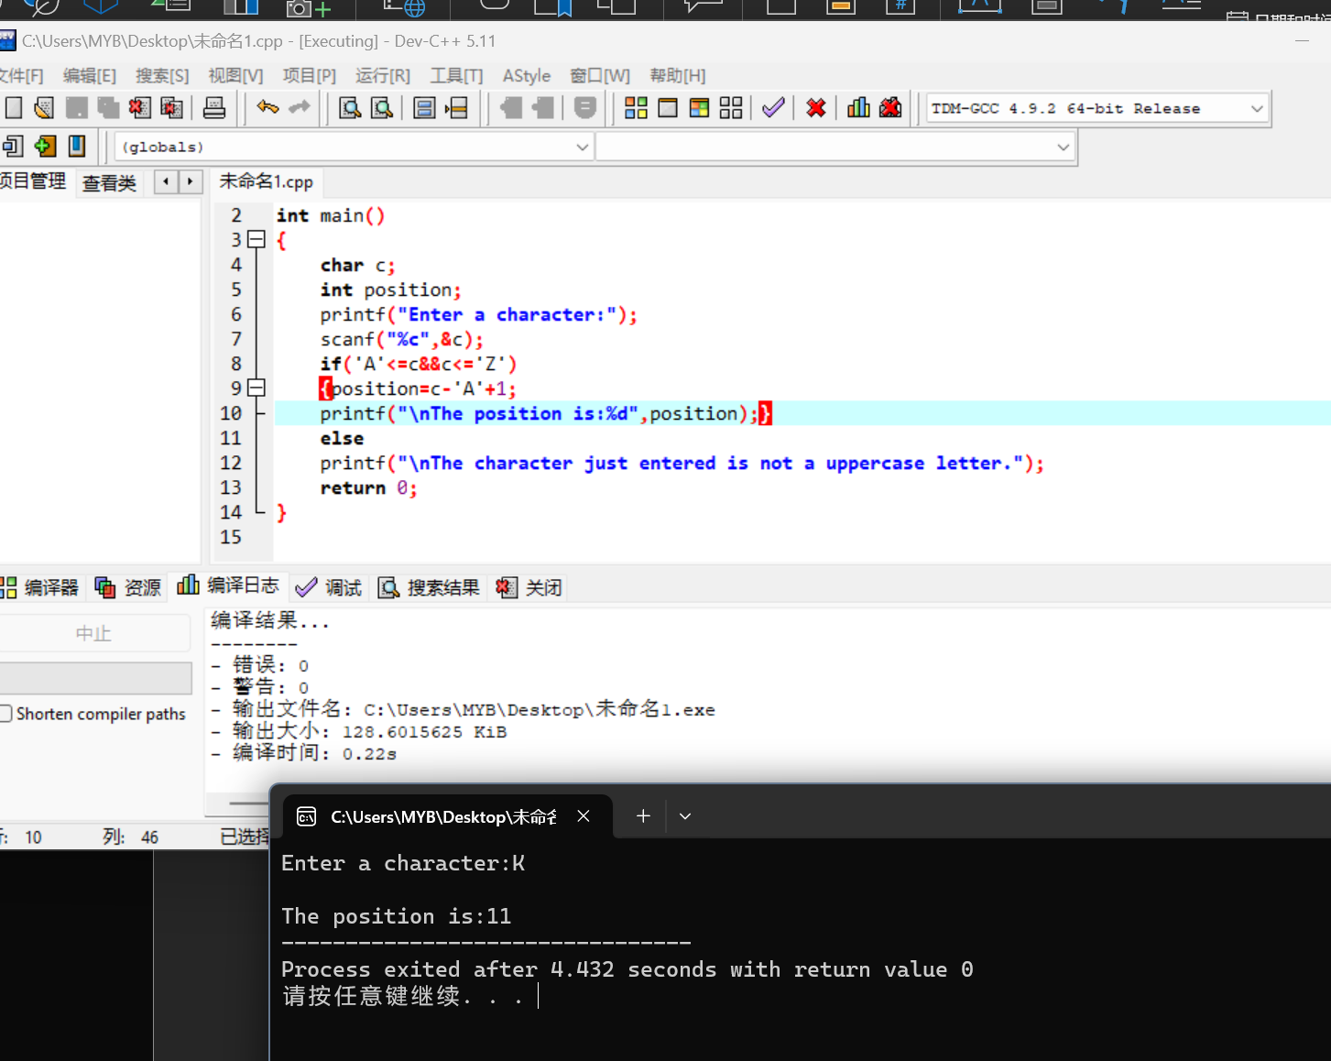

131.1

#include <stdio.h>

int main()

{

float grade;

printf("Enter the numercial grade:");

scanf("%f",&grade);

if(grade>=90)

printf("A");

else if(grade>=80)

printf("B");

else if(grade>=70)

printf("C");

else if(grade>=60)

printf("D");

else

printf("F");

return 0;

}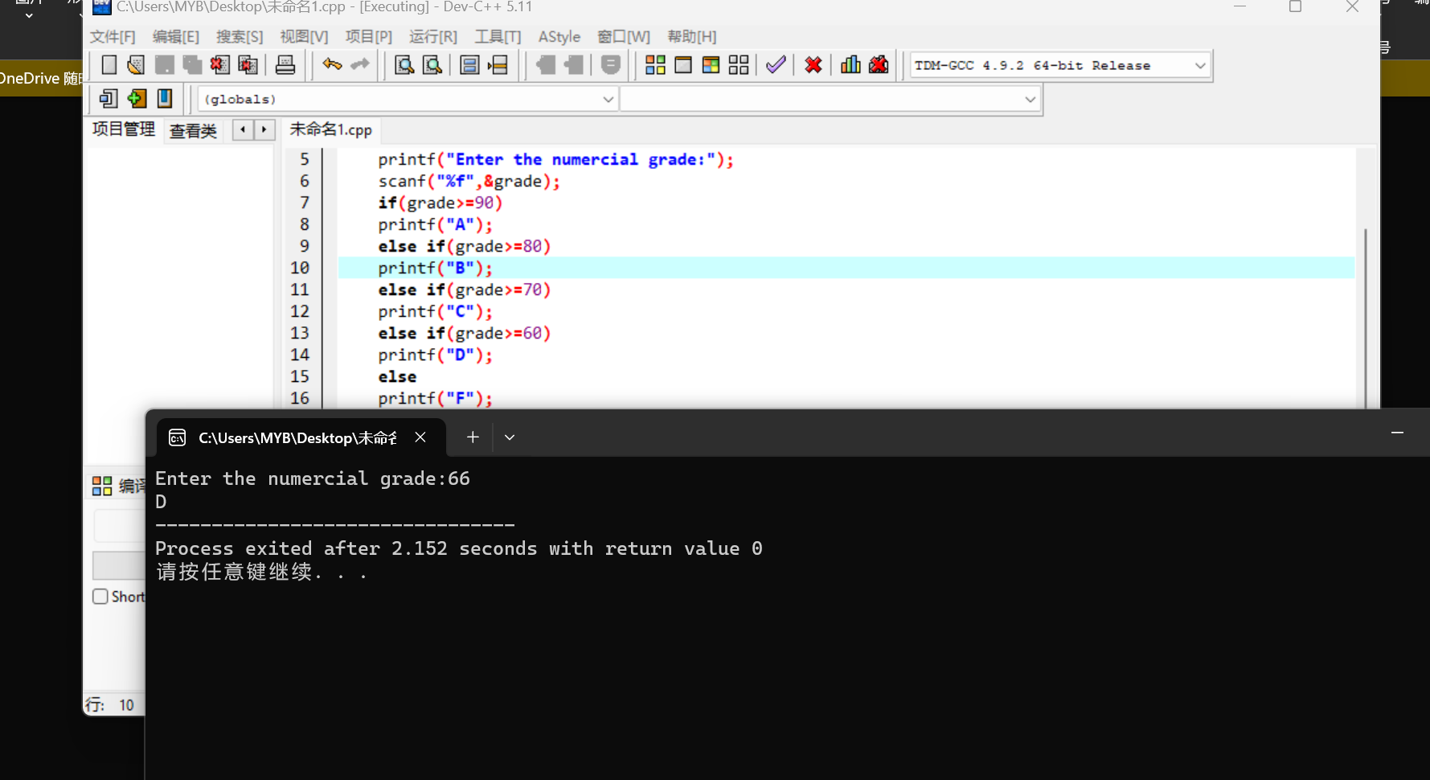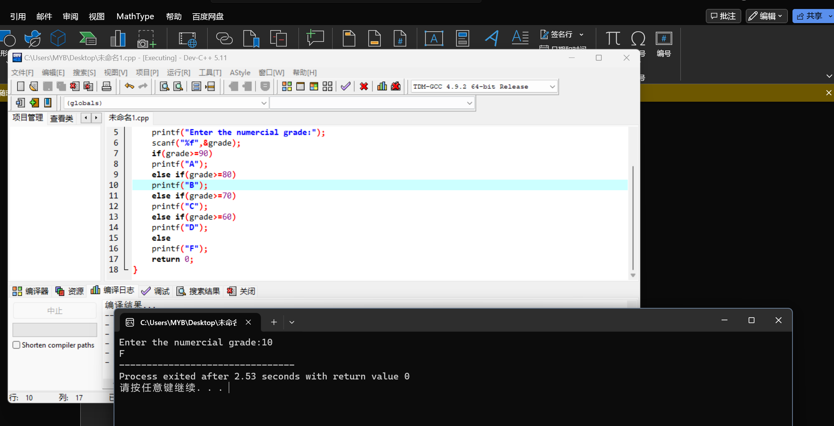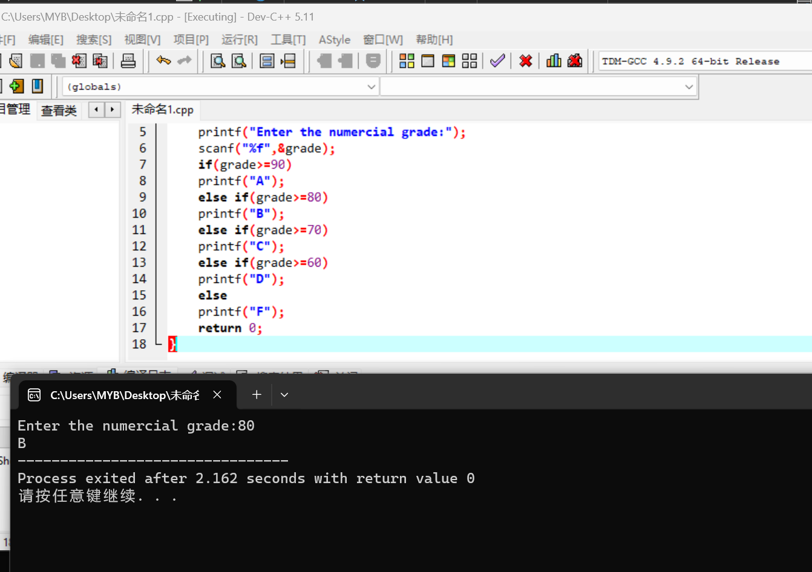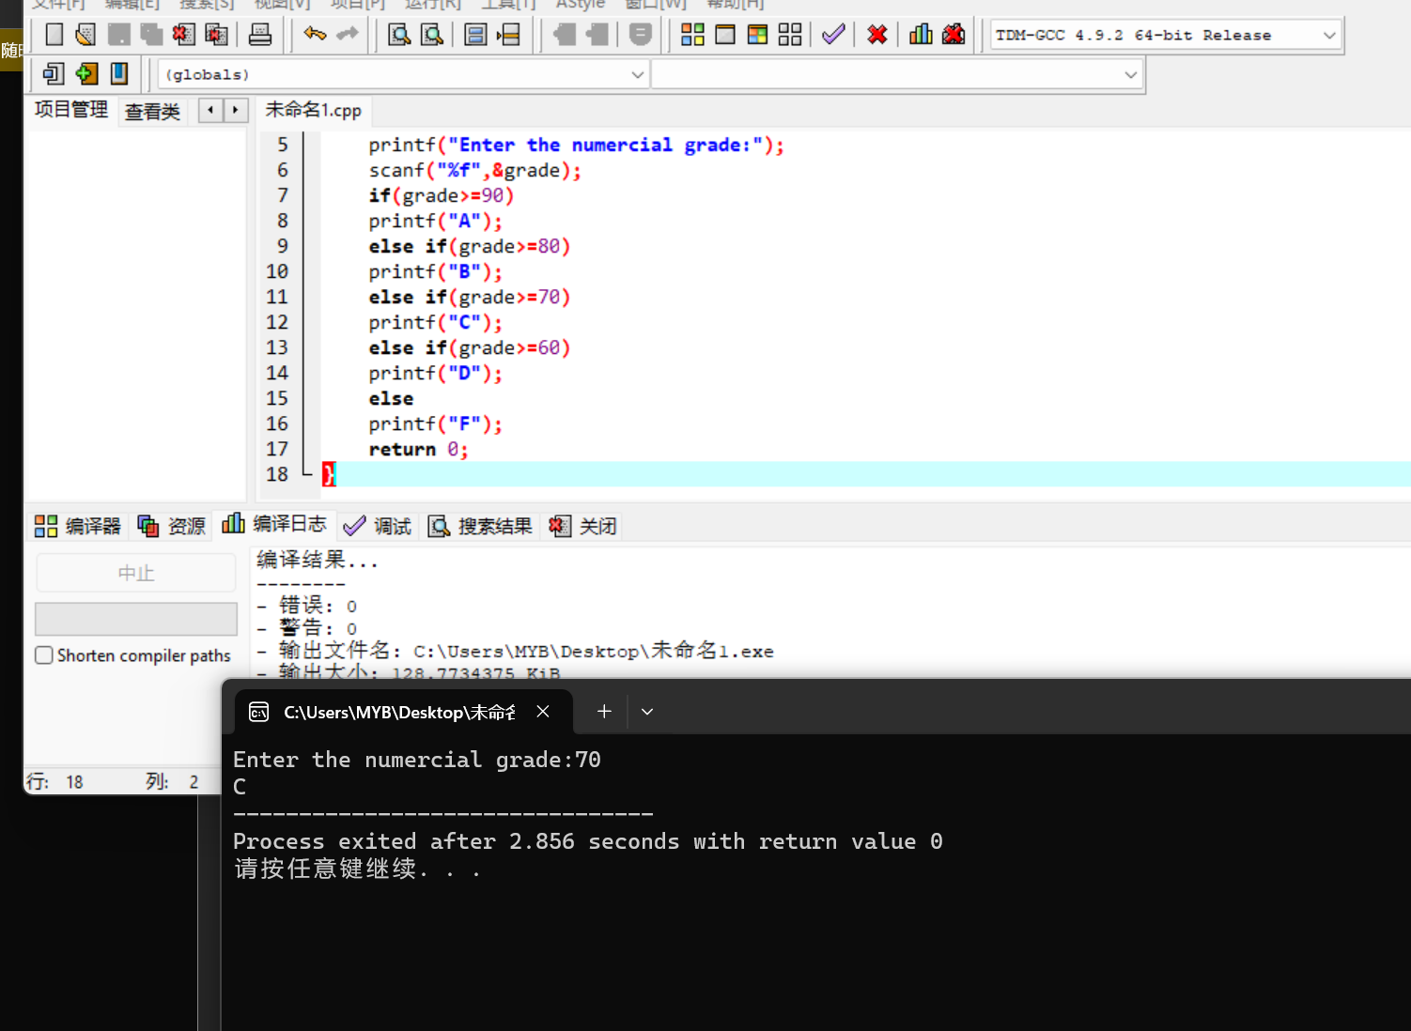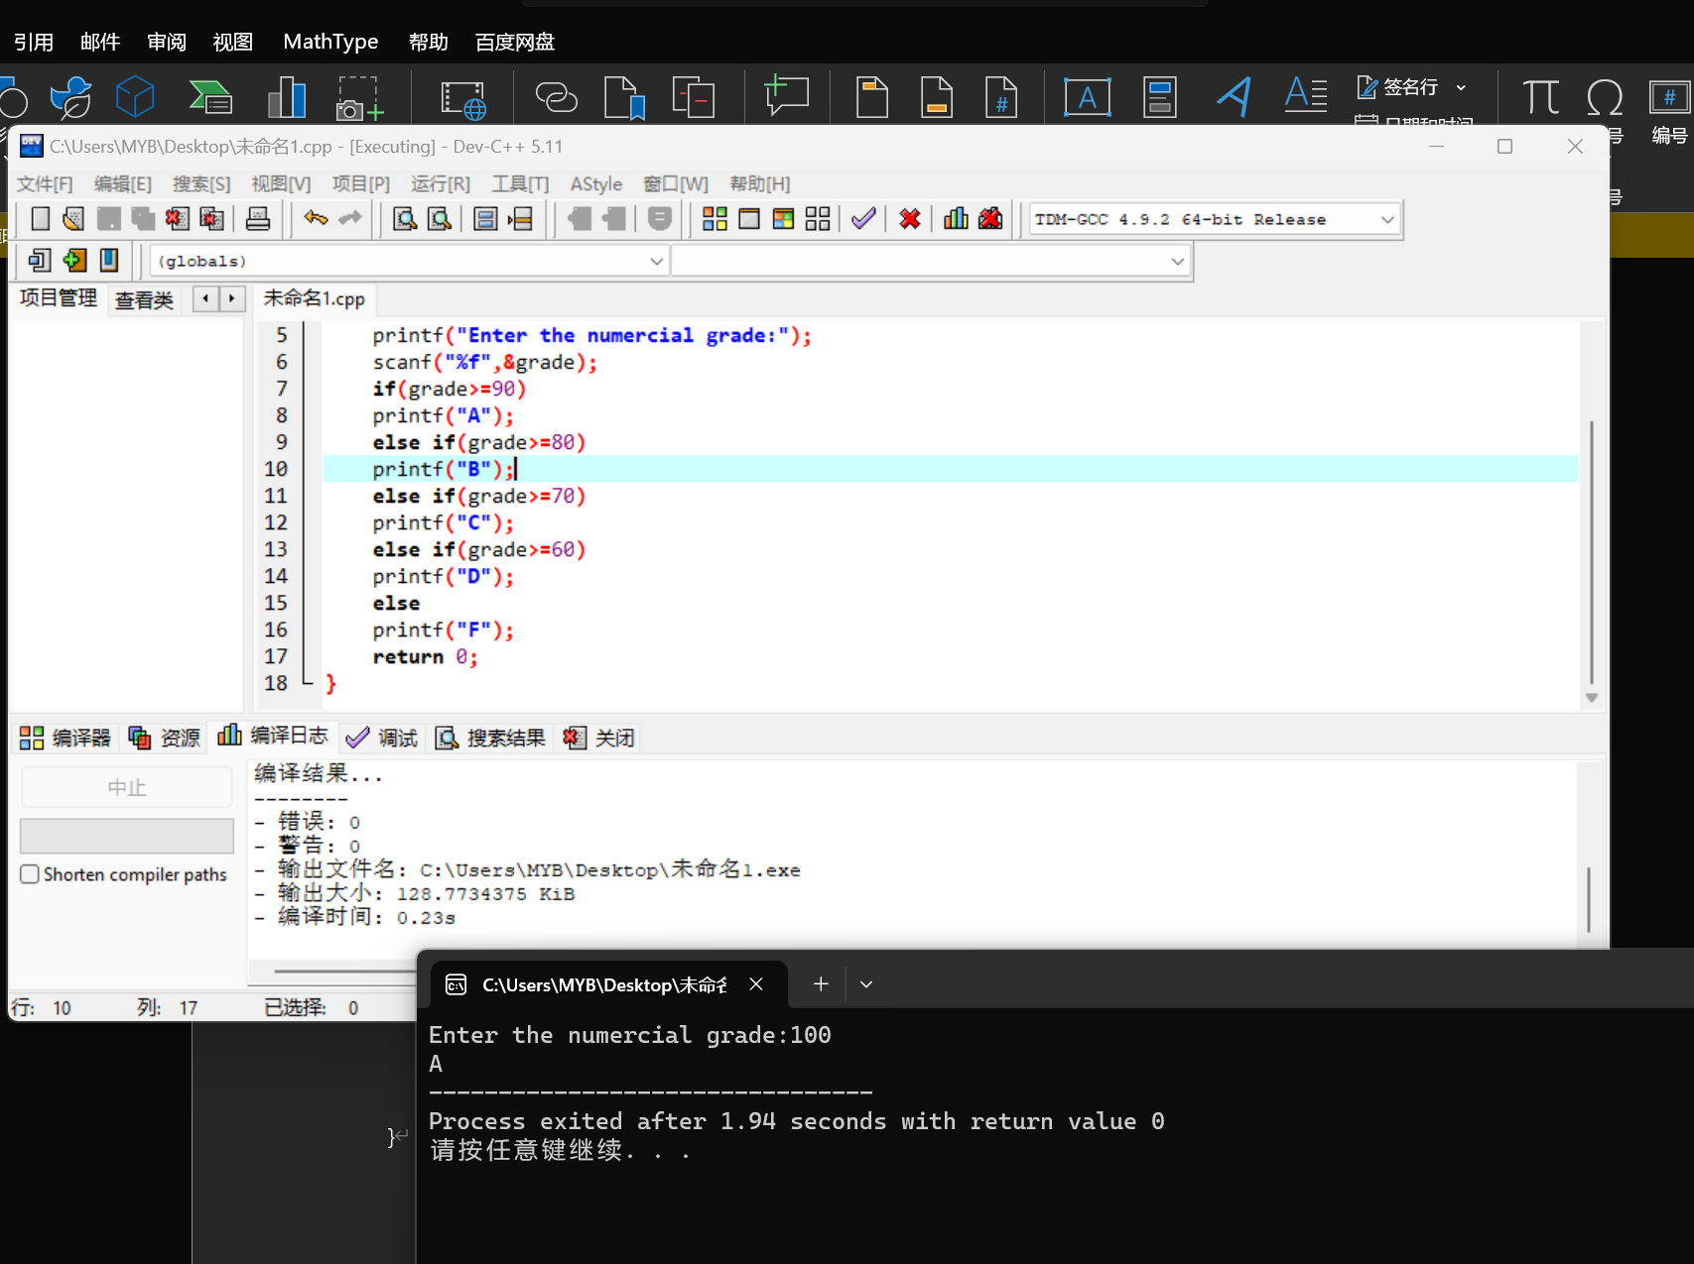

132.2

#include <stdio.h>

int main()

{

float time;

printf("Enter the time:");

scanf("%f",&time);

if(time>=5)

printf("rate=.045");

else if(time>=4)

printf("rate=.04");

else if(time>=3)

printf("rate=.035");

else if(time>=2)

printf("rate=.3");

else if(time>=1)

printf("rate=.025");

else

printf("rate=.02");

return 0;

}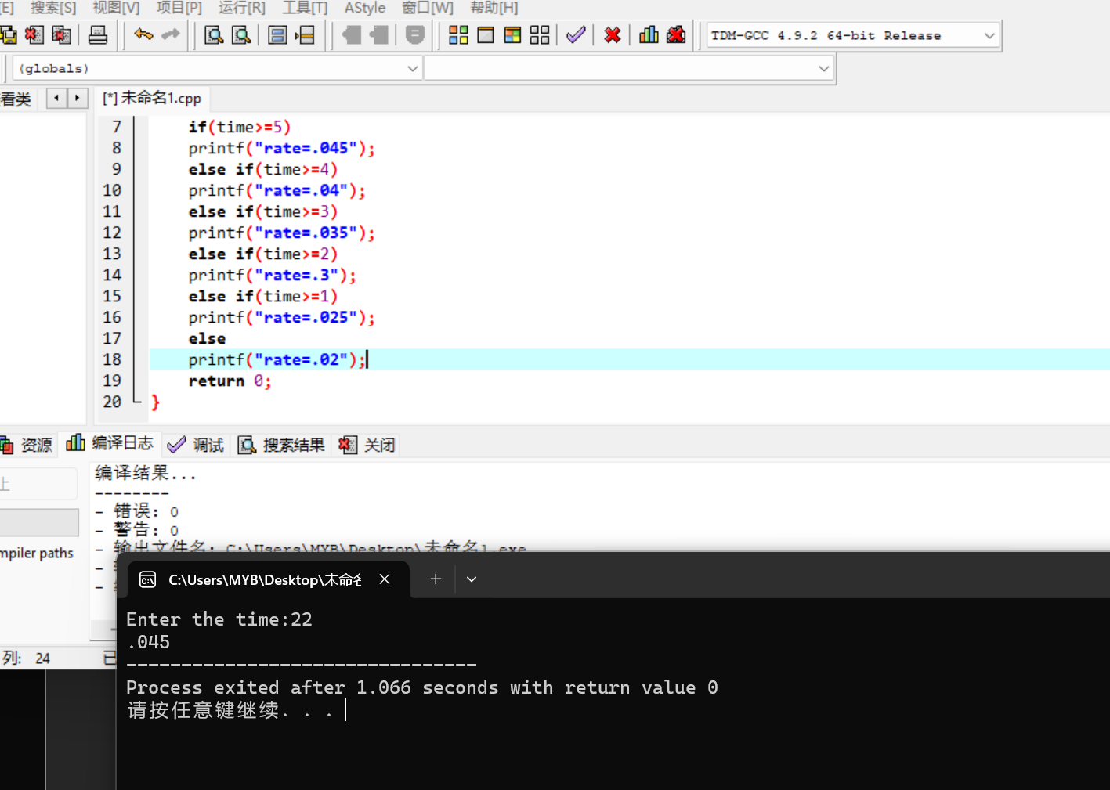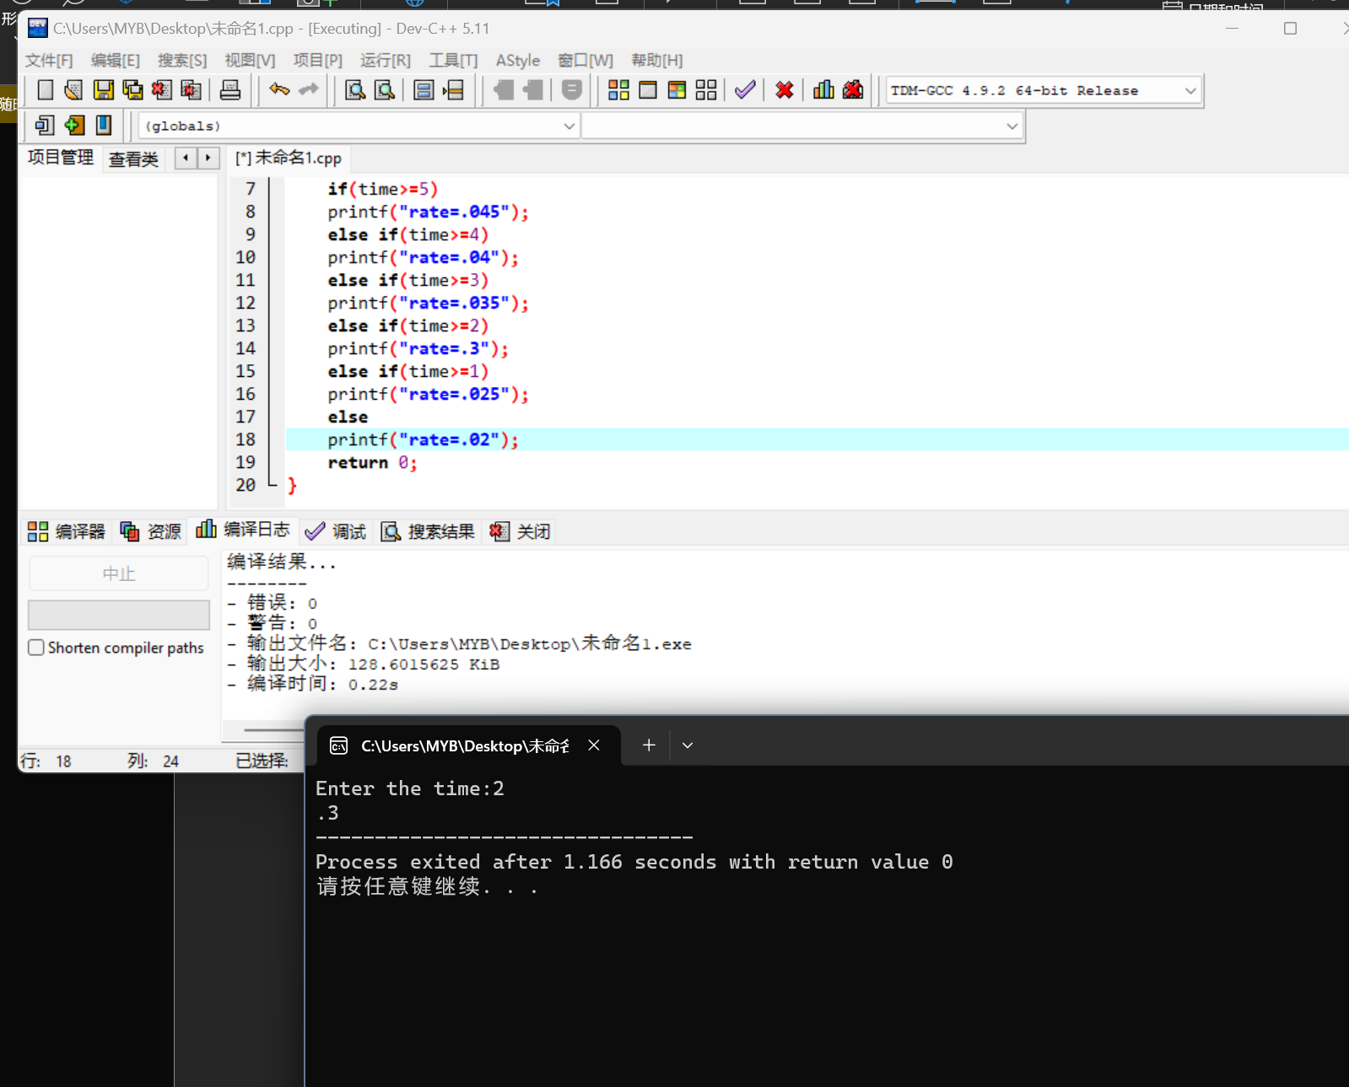

132.3

#include <stdio.h>

int main()

{

float temp,C,F;

char sign;

printf("Enter the temperature (use number add space and sign of the f or c):");

scanf("%d %c",&temp,&sign);

if(sign=='f')

{C=(5.0/9.0)\*(temp-32.0);

printf("Celsius is %f",C);}

else if(sign=='c')

{F=(9.0/5.0)\*(temp+32.0);

printf("Fahrenheit is %f",F);}

else

printf("The data entered is incorrect and terminate");

}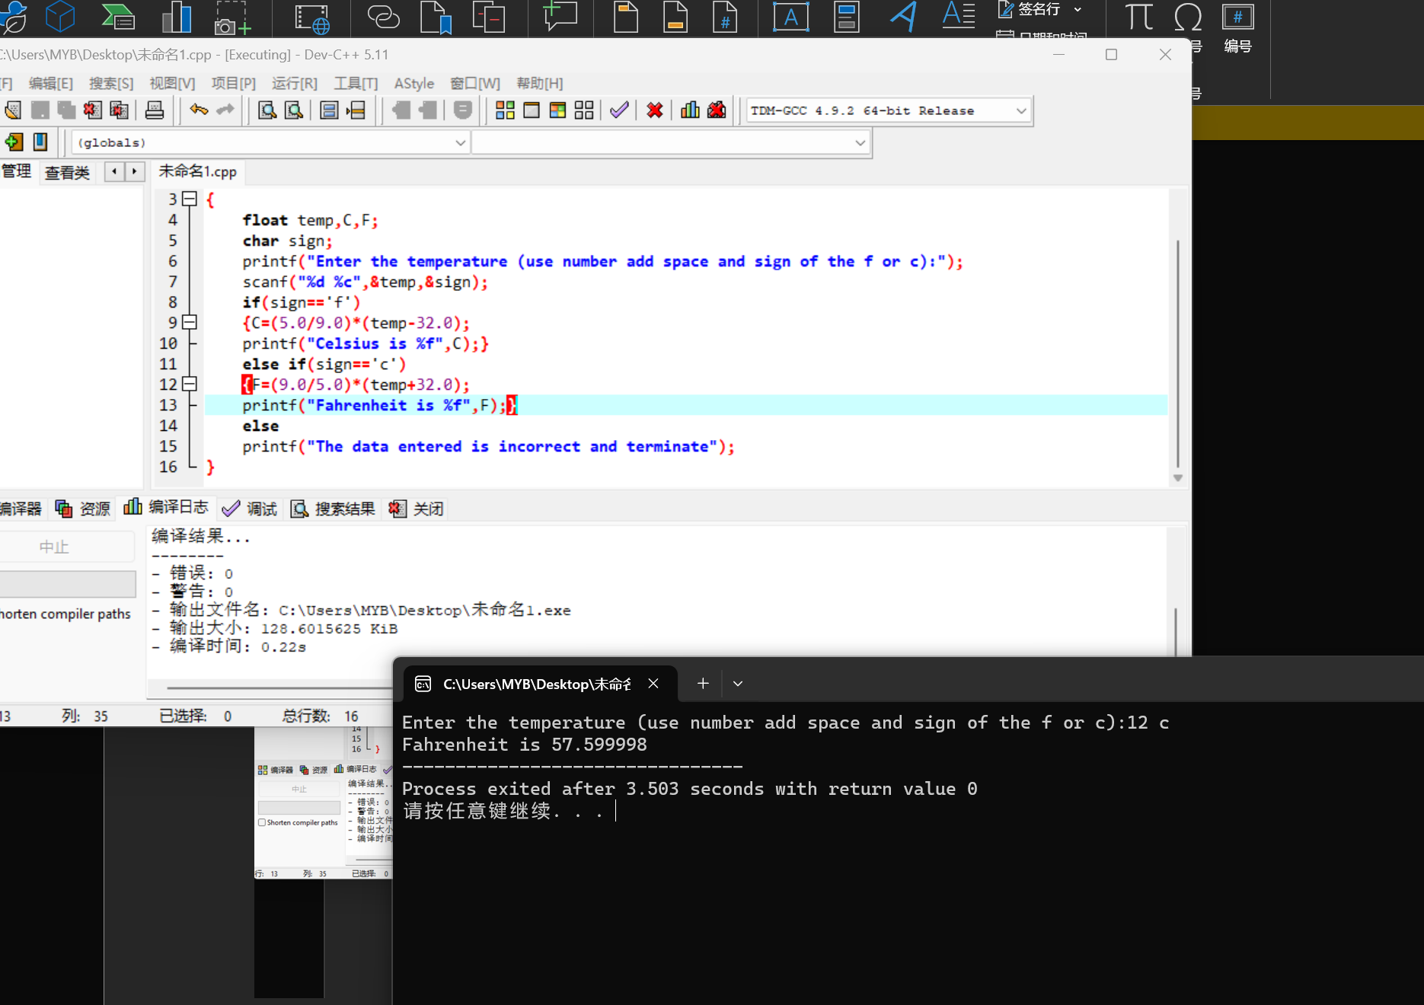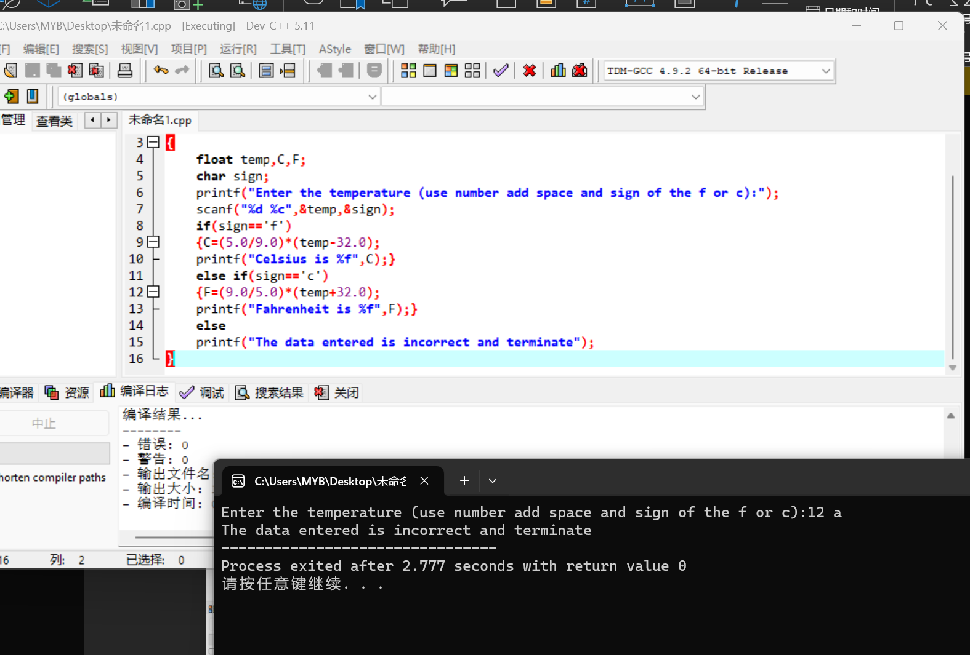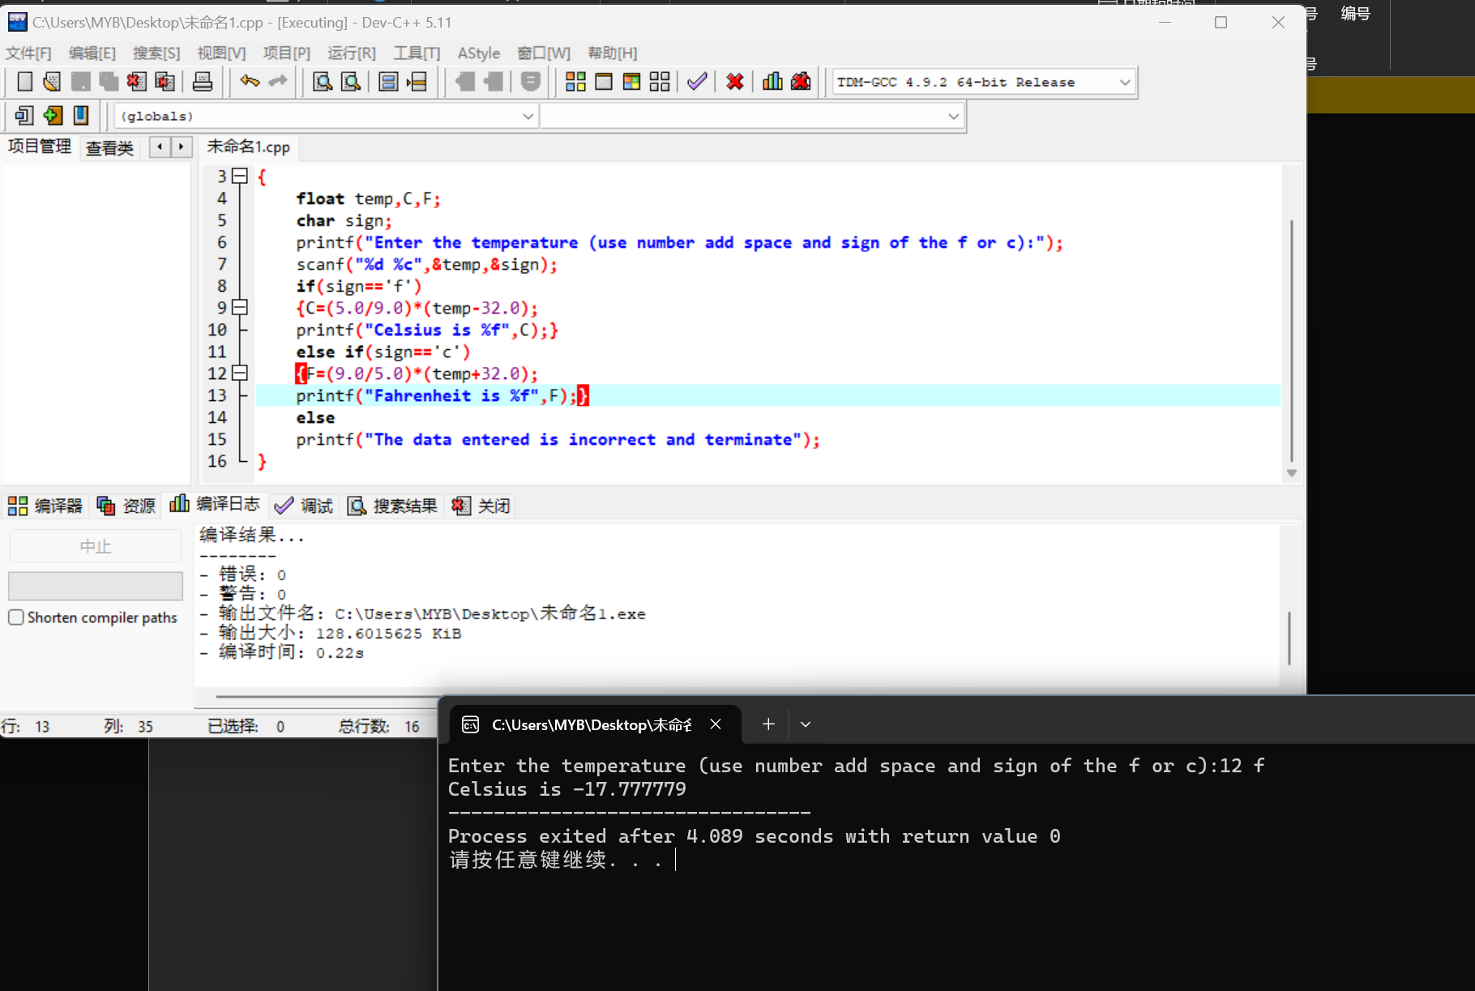

137.1

#include <stdio.h>

int main()

{

int code;

printf("Enter the Code:");

scanf("%d",&code);

switch(code)

{

case 1:

printf("3M Corporation");

break;

case 2:

printf("Maxell Corparation");

break;

case 3:

printf("Sony Corporation");

break;

case 4:

printf("Verbatim Corporation");

break;

}

return 0;

}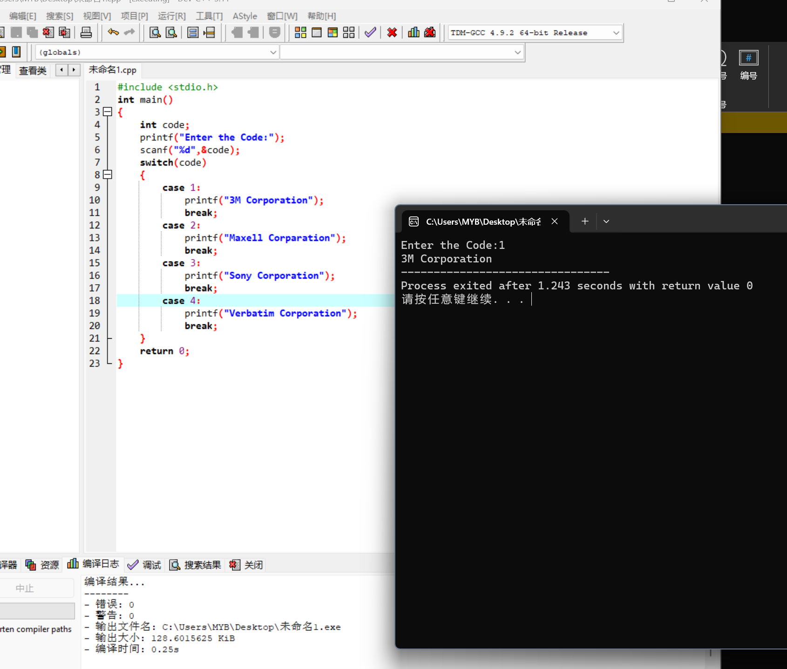

137.2

#include <stdio.h>

int main()

{

char marcode;

printf("Enter a marital code:");

scanf("%c",&marcode);

switch(marcode)

{

case 'M':

printf("\nIndividual is married.\n");

break;

case 'S':

printf("\nIndividual is single.\n");

break;

case 'D':

printf("\nIndividual is divorced.\n");

break;

case 'W':

printf("\nIndividual is widowed.\n");

break;

default:

printf("\nAn invalid code was entered.\n");

break;

}

return 0;

}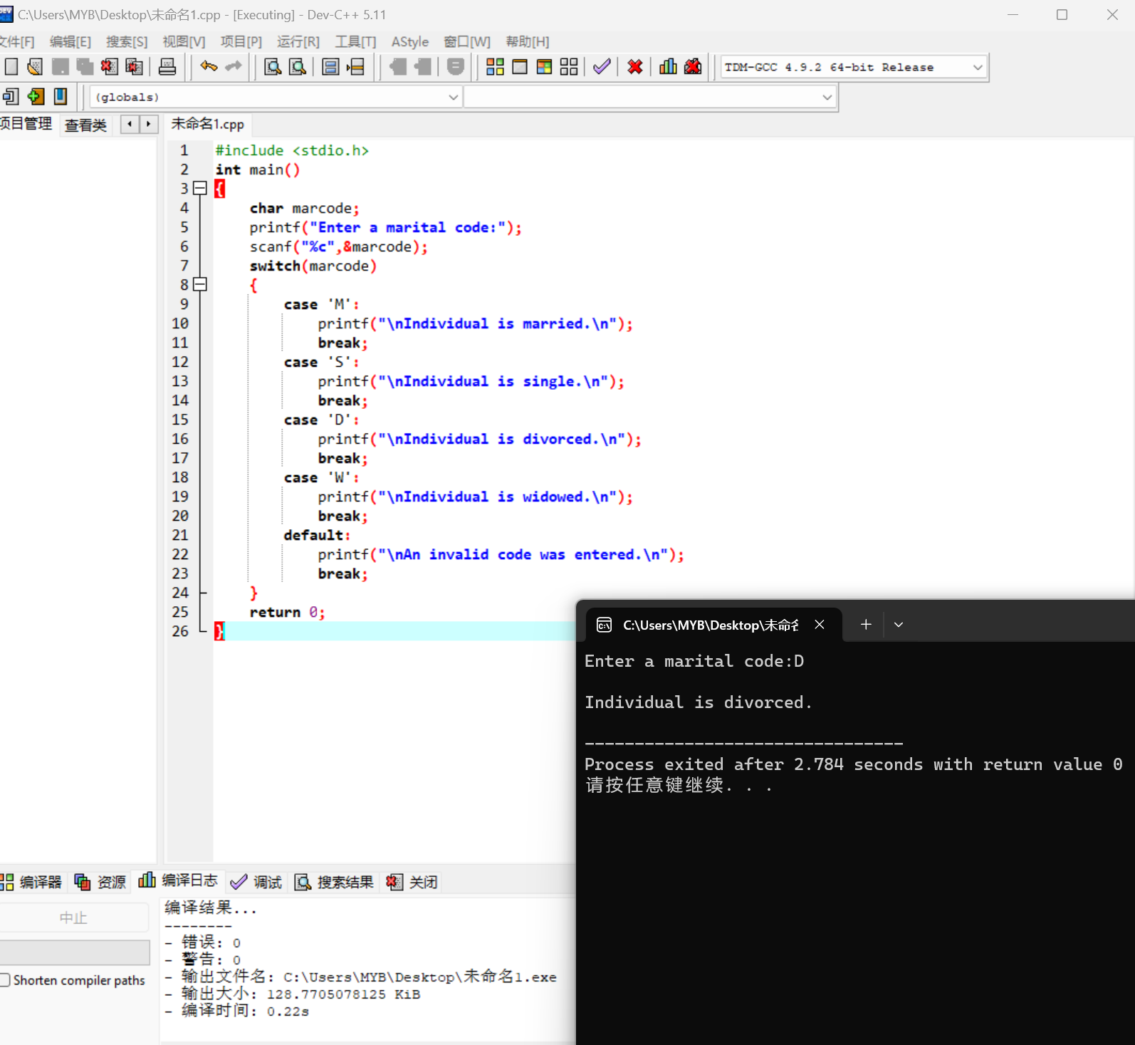

138.5

#include <stdio.h>

int main()

{

char opselect;

float fnum,snum;

printf("Please type in two numbers:");

scanf("%f %f",&fnum,&snum);

printf("Enter a select code:");

printf("\n 1 for addition");

printf("\n 2 for multipication");

printf("\n 3 for division");

scanf("\n%c",&opselect);

switch(opselect)

{

case '1':

printf("The sum of the numbers entered is %6.3f\n",fnum+snum);

break;

case '2':

printf("The product of the numbers entered is %6.3f\n",fnum\*snum);

break;

case '3':

if (snum!=0.0)

printf("The first number divided by the second is %6.3f\n",fnum/snum);

else

printf("Division bu zero is not allowed\n");

break;

}

return 0;

}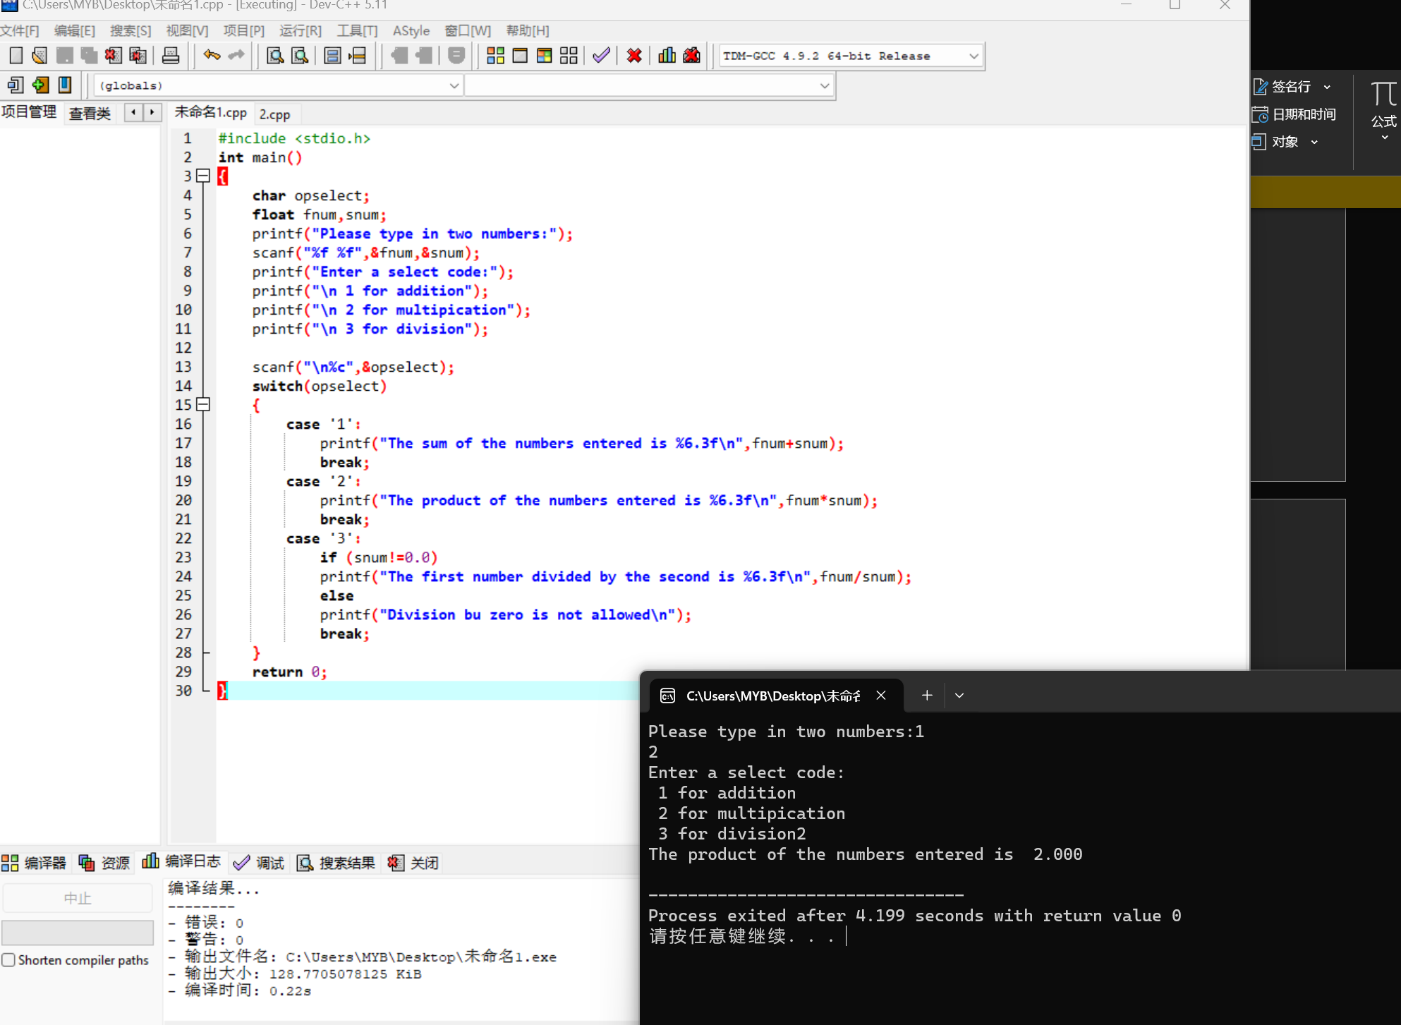

140.1.a

#include <stdio.h>

int main()

{

int month,day;

printf("Enter a month (use a 1 for Jan,etc.)");

scanf("%d",&month);

printf("Enter aday of the month:”);

scanf("%d",&day);

if(month<1||month>12)

printf("\nMonth is invalid");

if(day<1||day>31)

printf("\nDay is invalid");

return 0;

}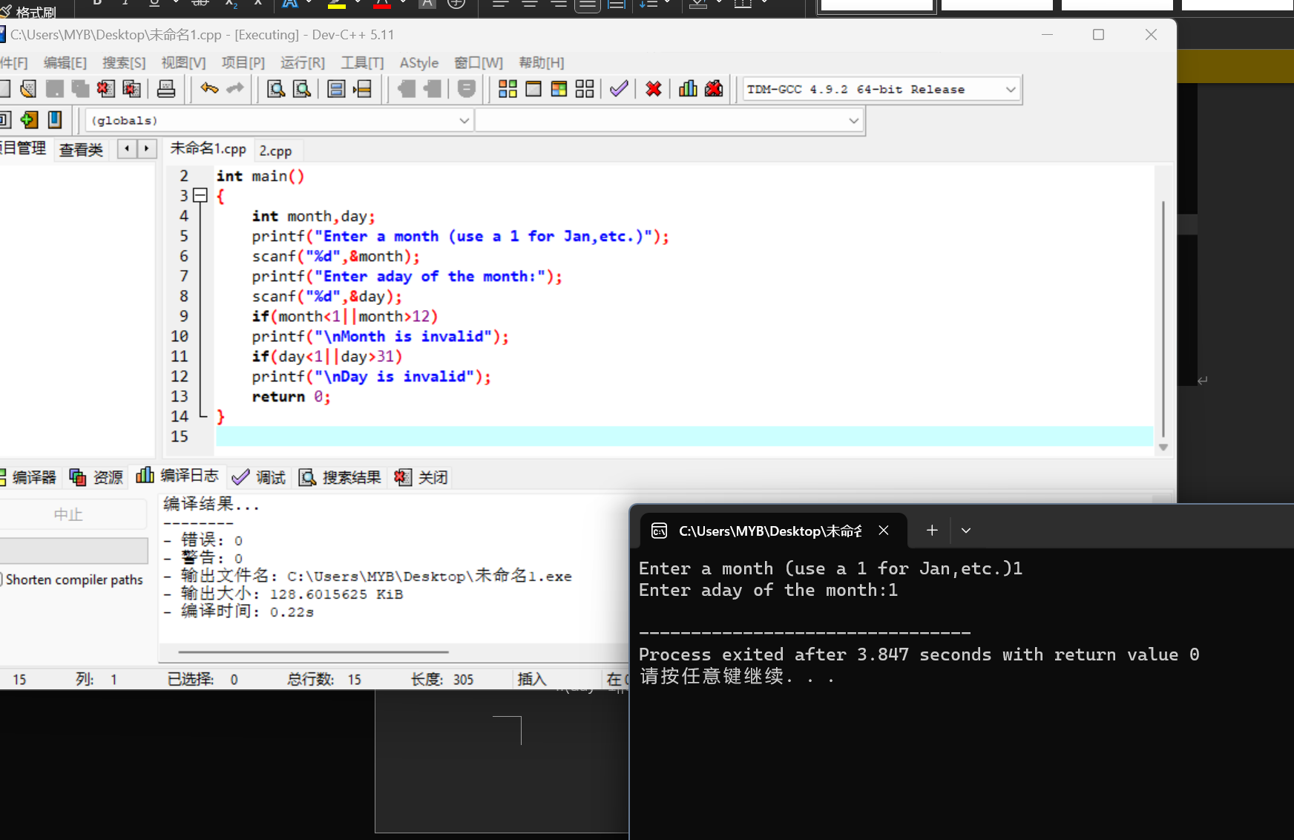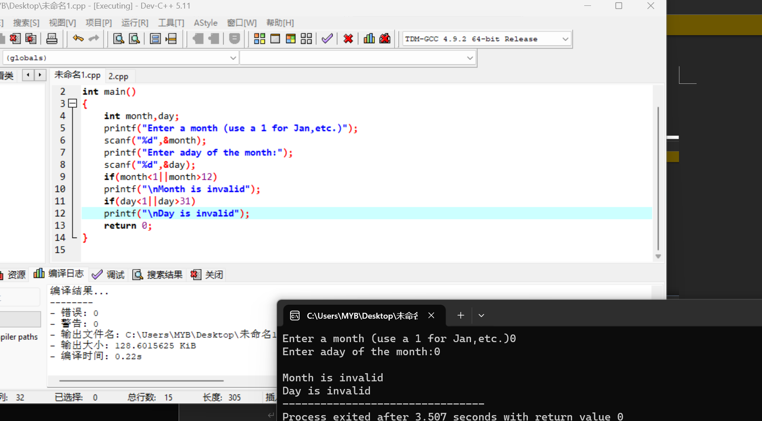

c.

#include <stdio.h>

int main()

{

int month,day;

printf("Enter a month (use a 1 for Jan,etc.)");

scanf("%d",&month);

printf("Enter a day of the month:");

scanf("%d",&day);

if(month<1||month>12)

printf("\nMonth is invalid");

switch(month)

{

case 1:case 3:case 5:case 7:case 8:case 10:case 12:

if(day>31||day<1)

printf("\nThe day is invalid in the month");

break;

case 2:

if(day>28||day<1)

printf("\nThe day is invalid in the month");

break;

case 4:case 6:case 9:case 11:

if(day>30||day<1)

printf("\nThe day is invalid in the month");

break;

}

return 0;

}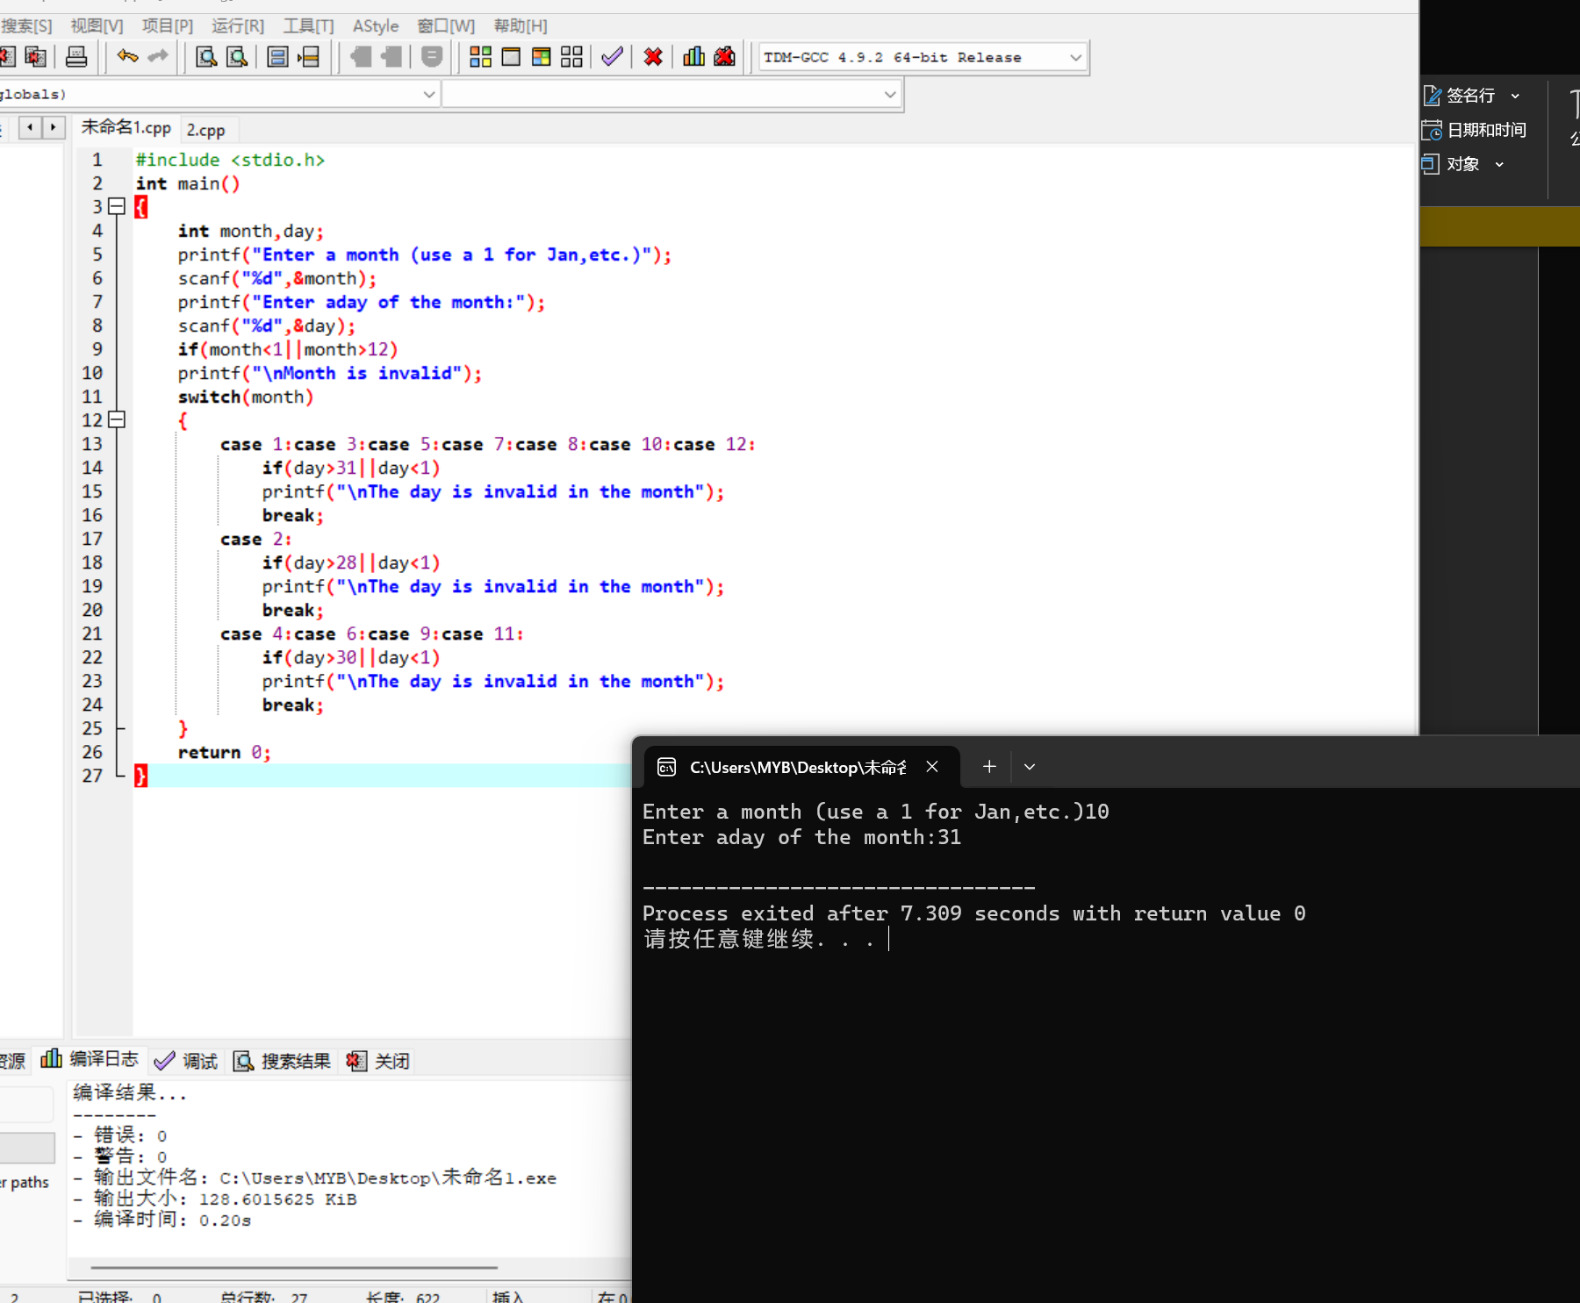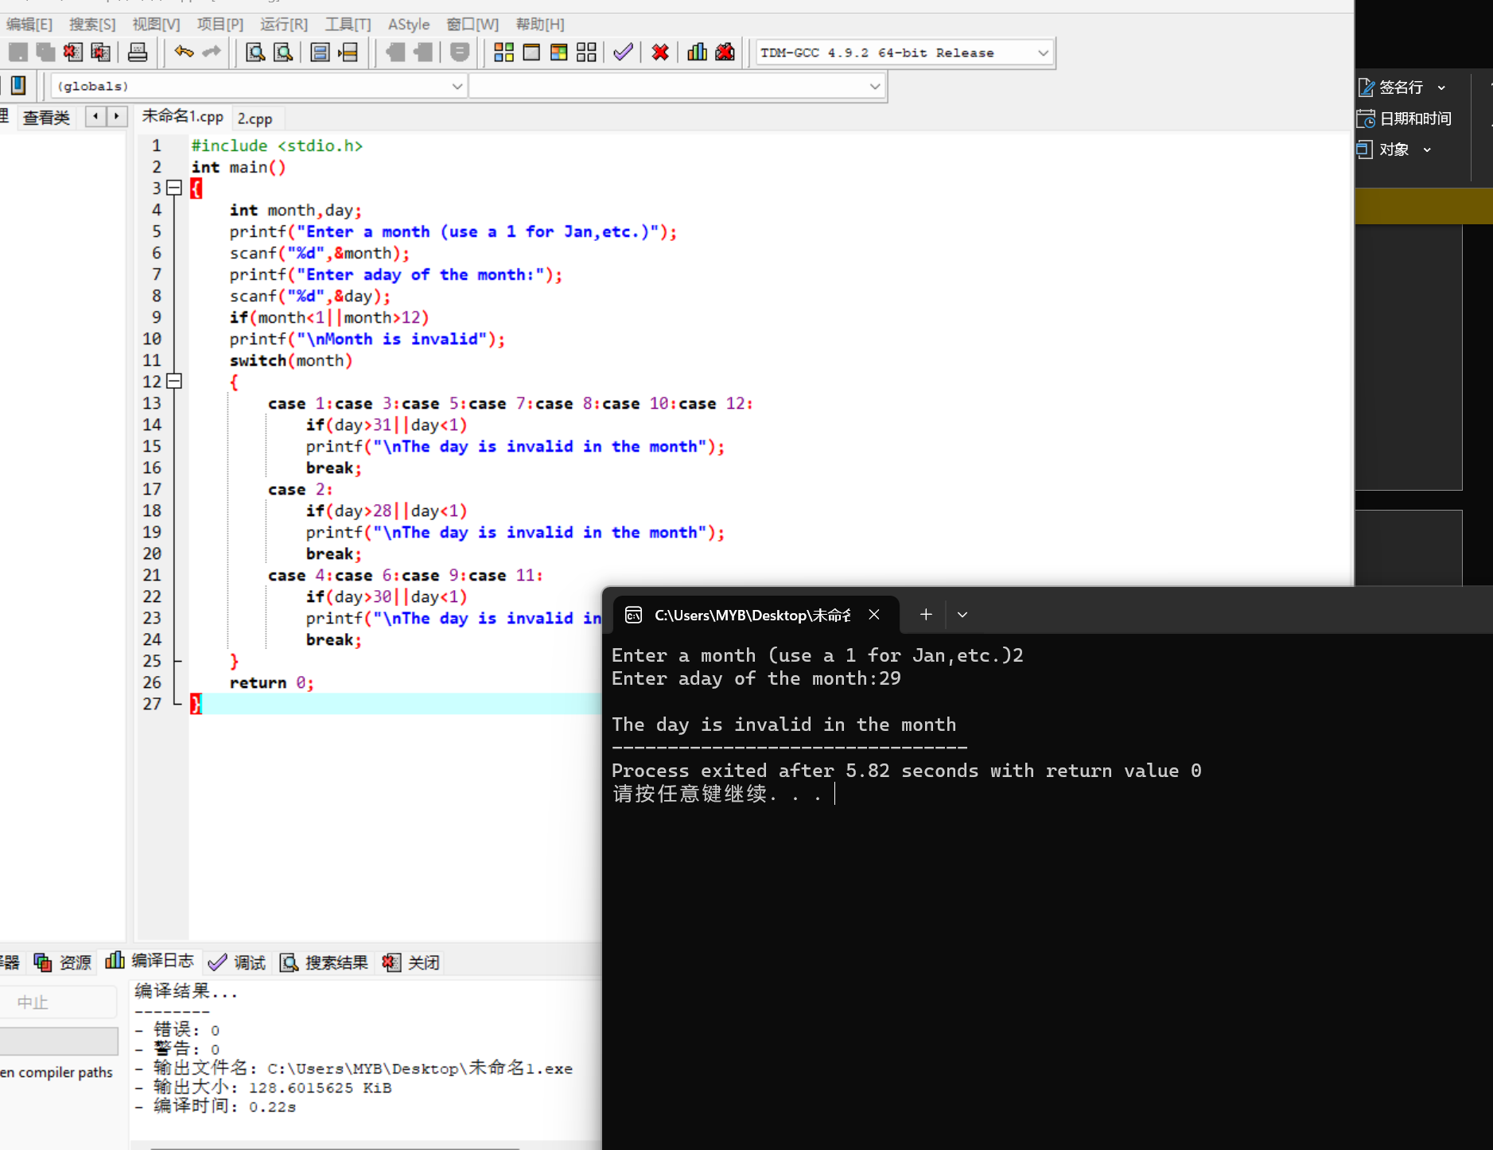

140.2

#include <stdio.h>

int main()

{

int angle;

printf("Enter the angle:");

scanf("%d",&angle);

if(angle>0&&angle<90)

printf("Quadrant is 1");

else if(angle>90&&angle<180)

printf("Quadrant is 2");

else if(angle>180&&angle<270)

printf("Quadrant is 3");

else if(angle>270&&angle<360)

printf("Quadrant is 4");

else if(angle==90||angle==180||angle==270)

printf("Lie on an axis");

return 0;

}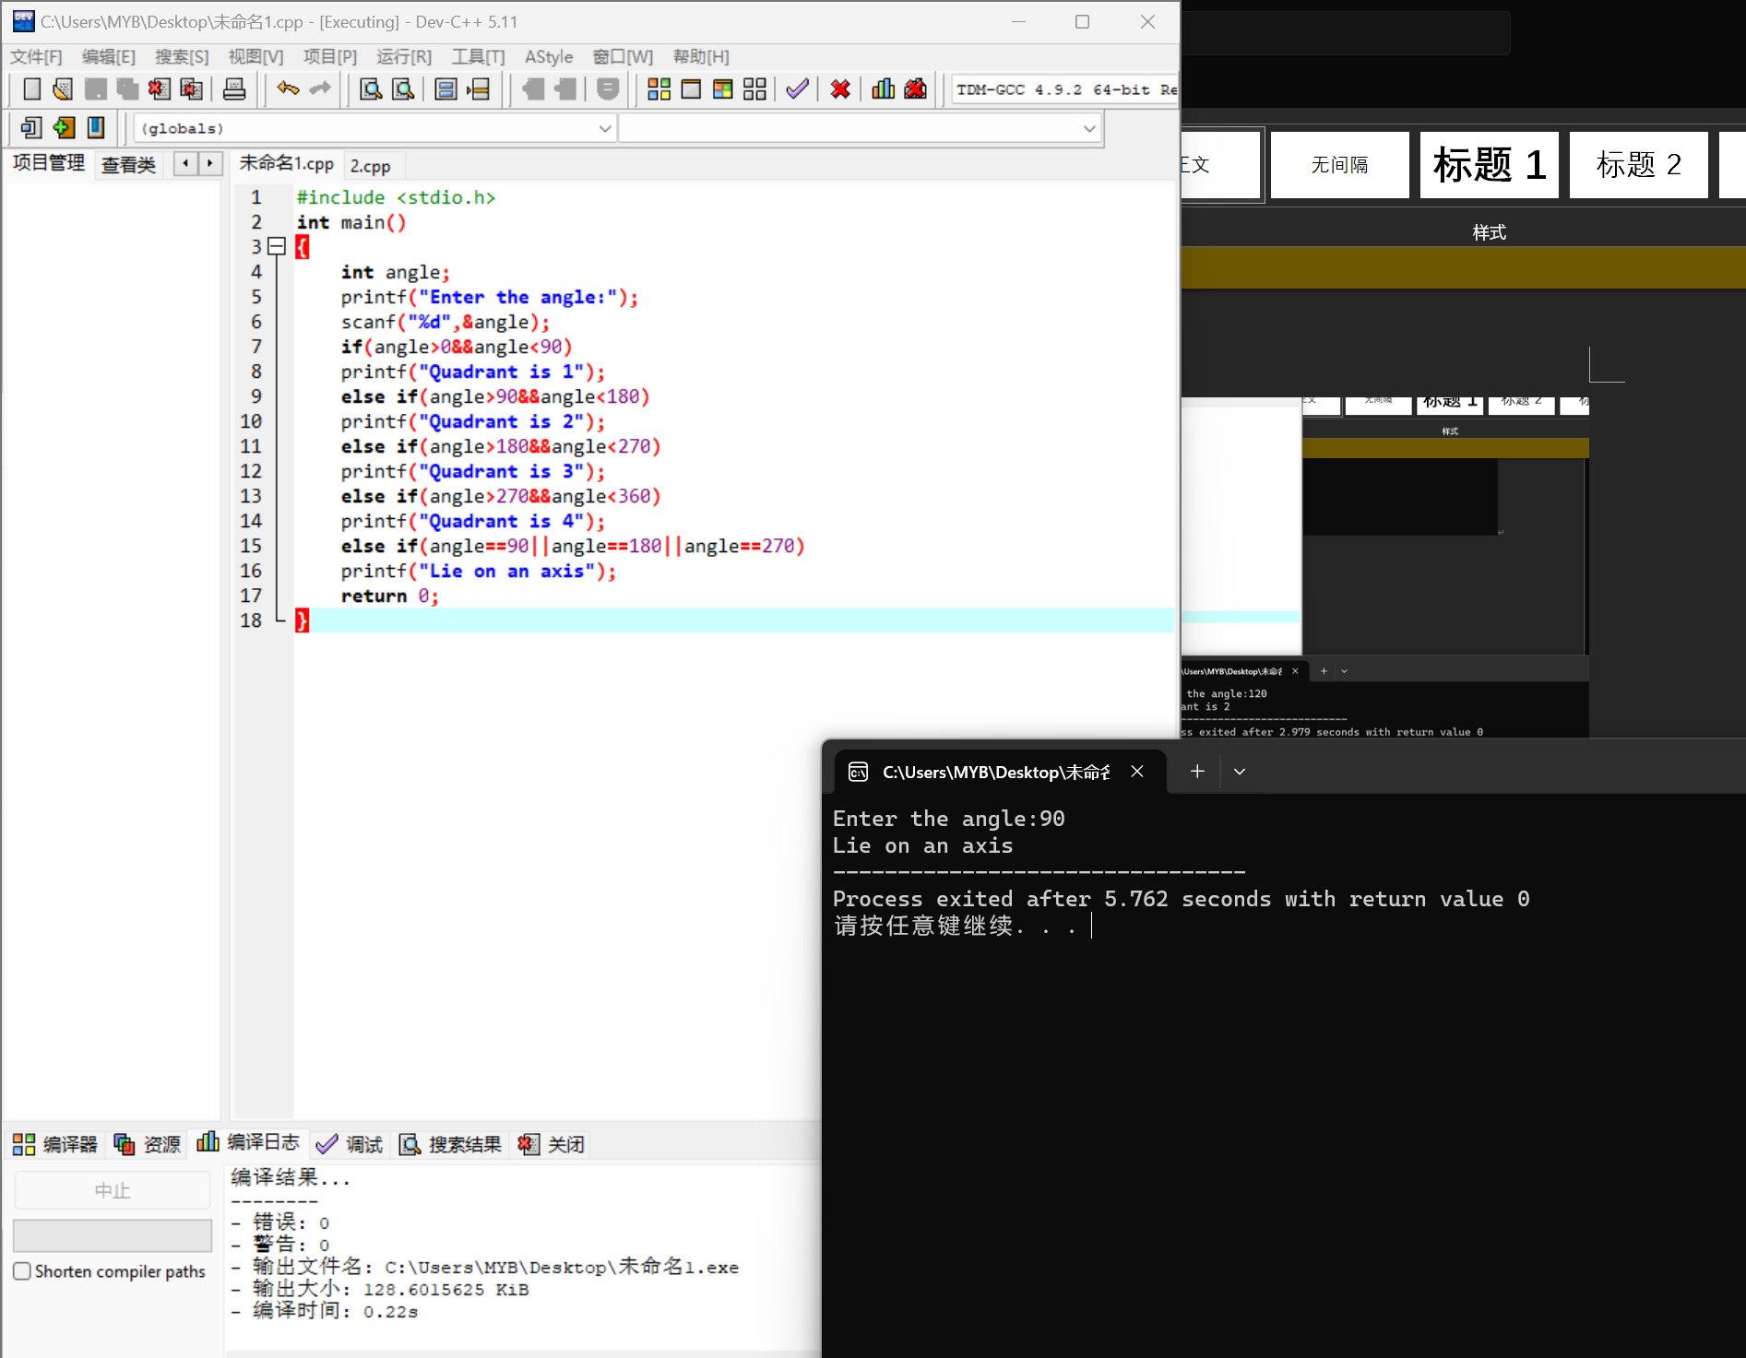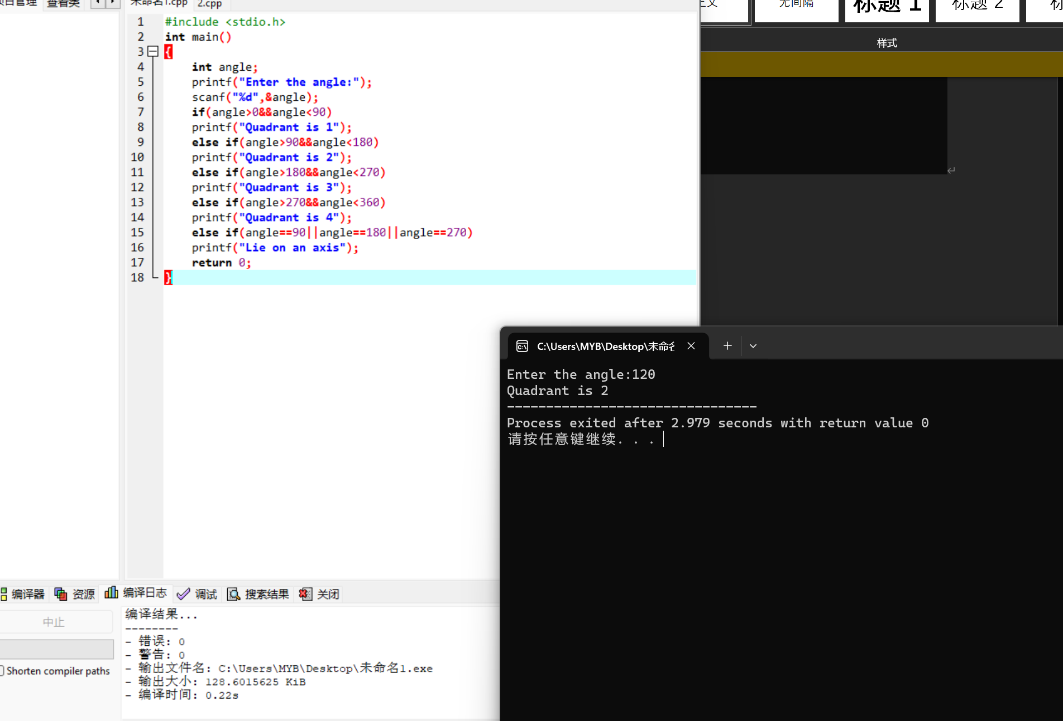

b.

#include <stdio.h>

int main()

{

int angle;

printf("Enter the angle:");

scanf("%d",&angle);

if(angle>0&&angle<90)

printf("Quadrant is 1");

else if(angle>90&&angle<180)

printf("Quadrant is 2");

else if(angle>180&&angle<270)

printf("Quadrant is 3");

else if(angle>270&&angle<360)

printf("Quadrant is 4");

else if(angle==0)

printf("The positive X-axis");

else if(angle==90)

printf("The positive Y-axis");

else if(angle==180)

printf("The negative X-axis");

else if(angle==270)

printf("The negative Y-axis");

return 0;

}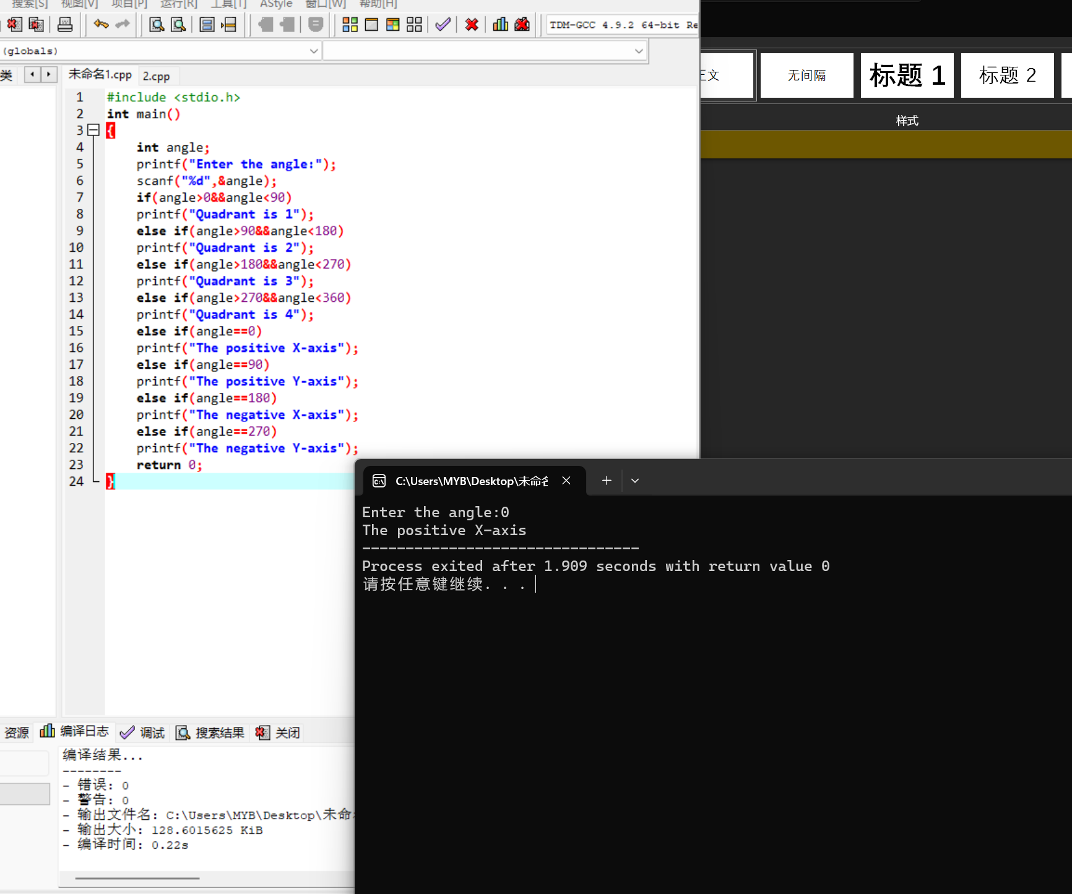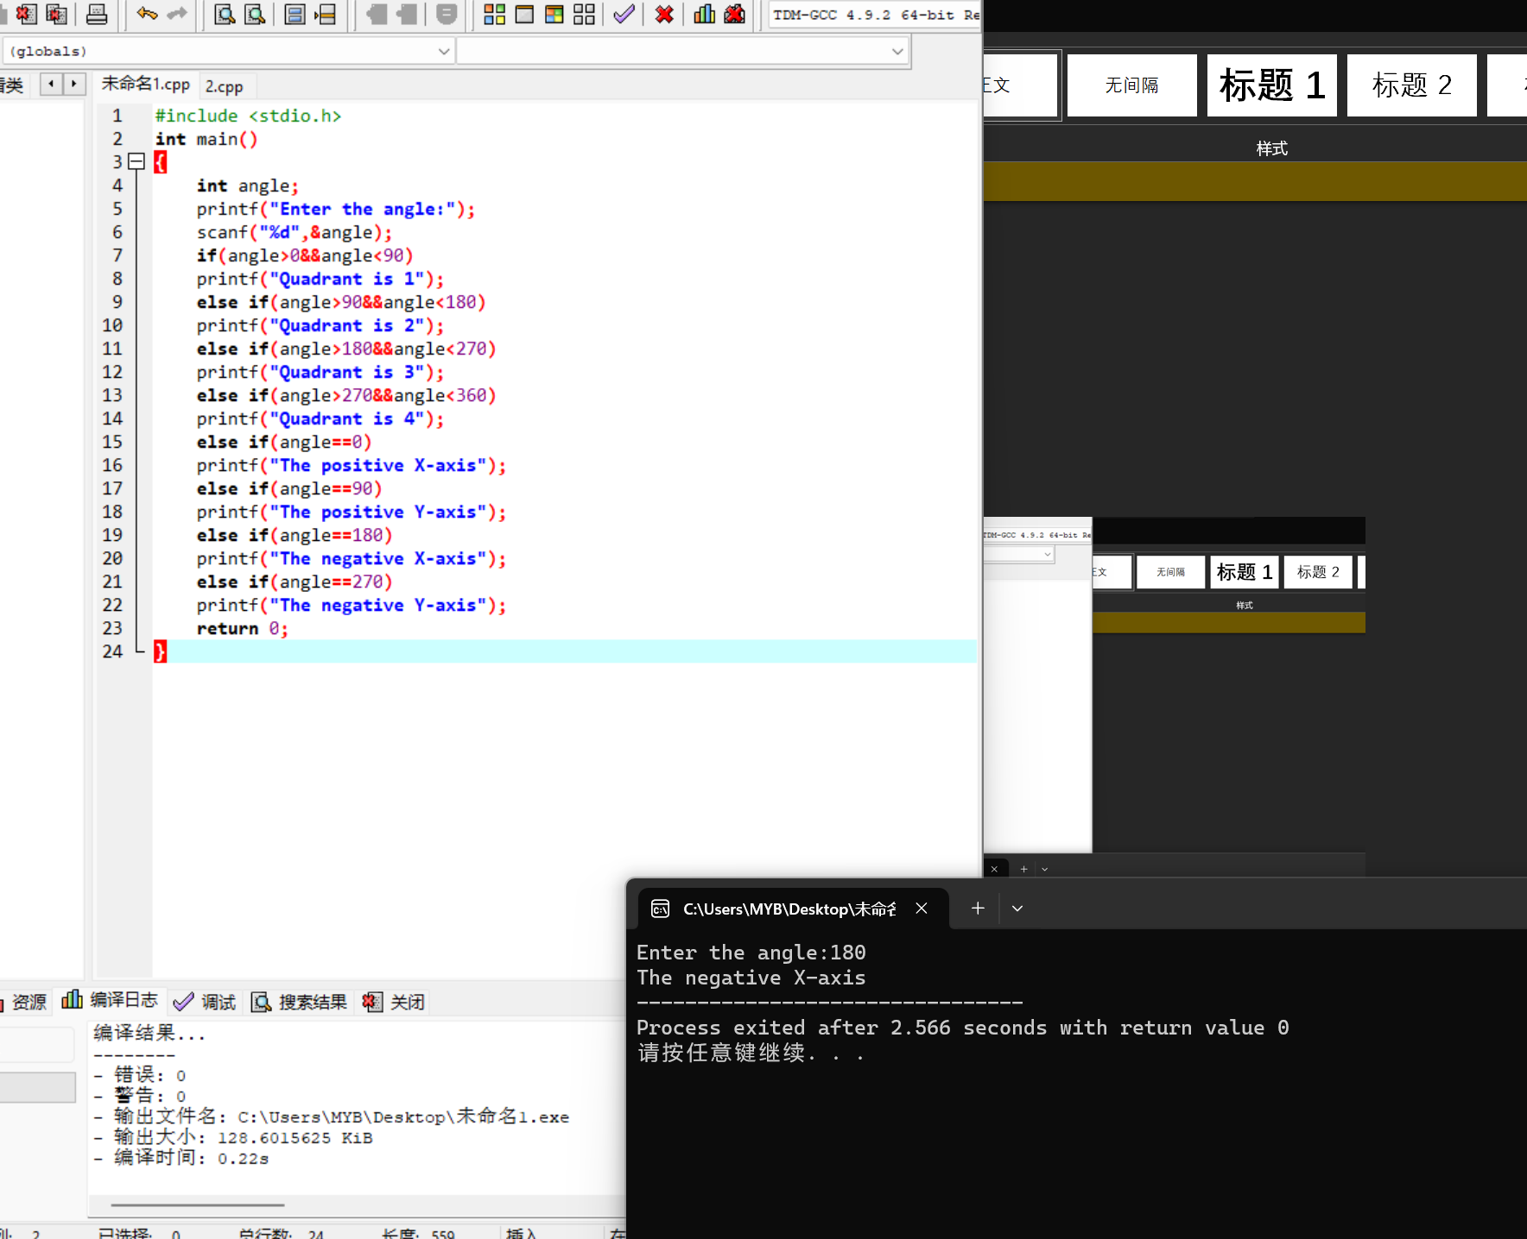

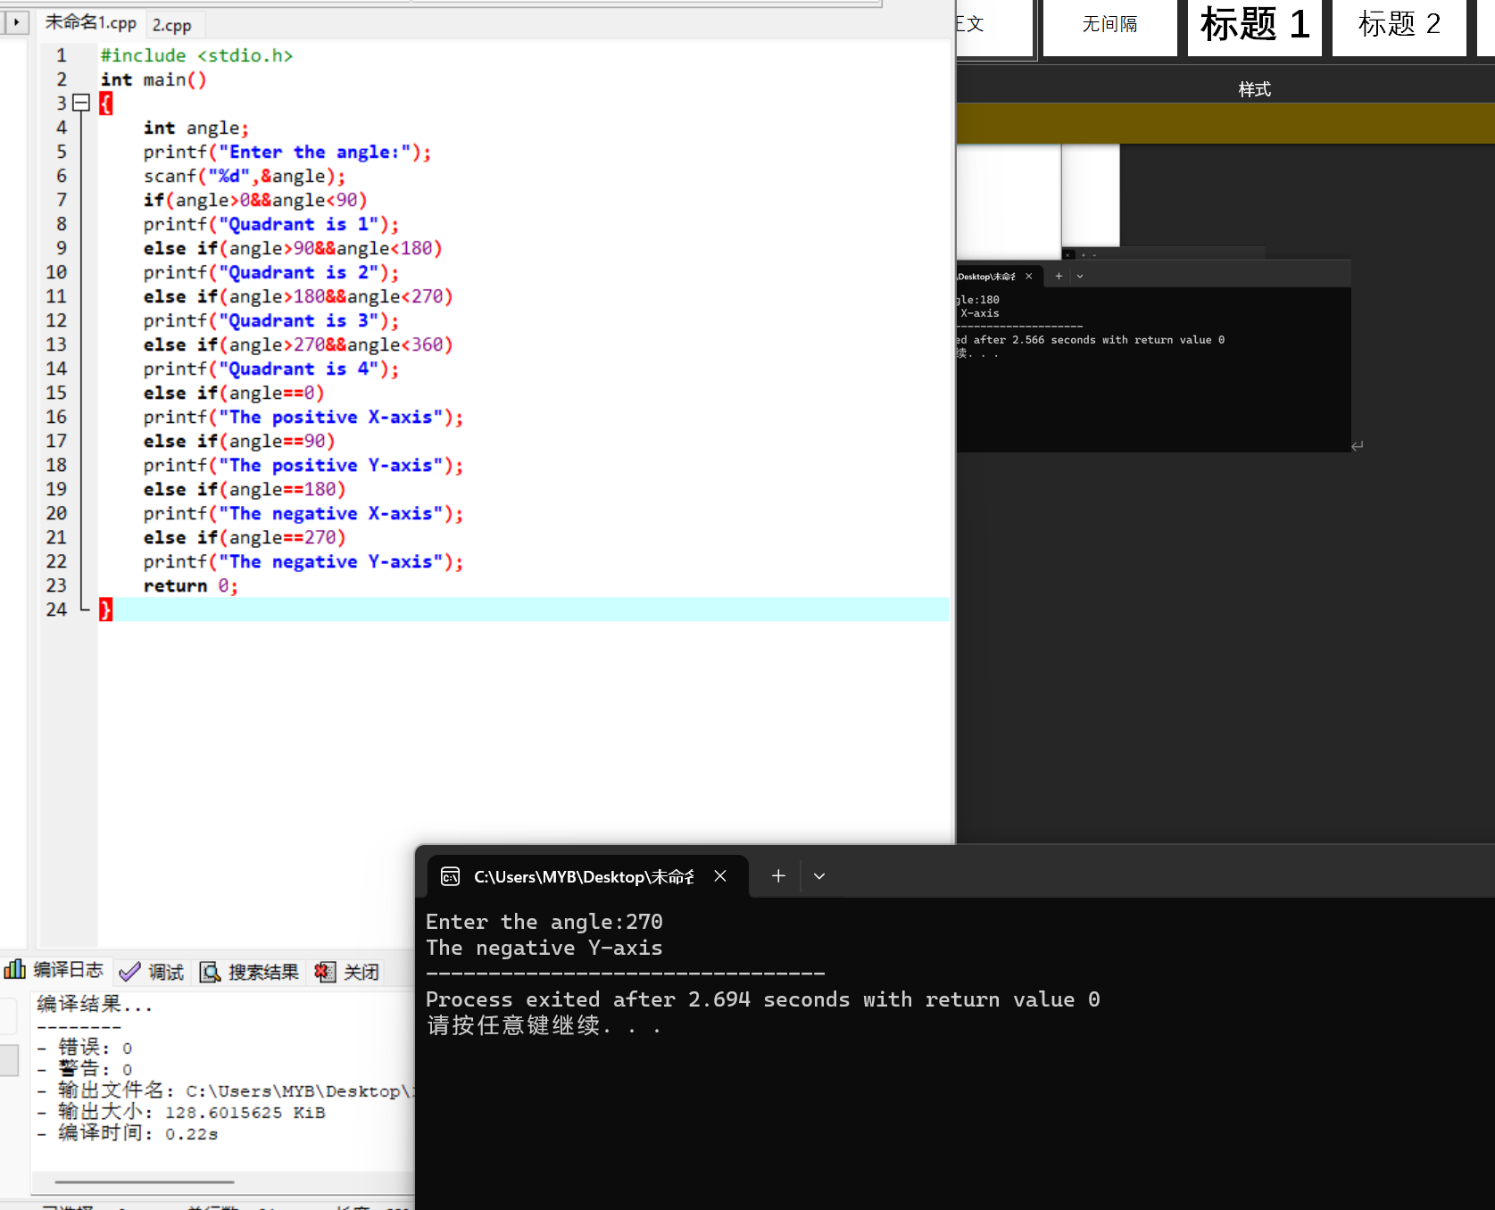

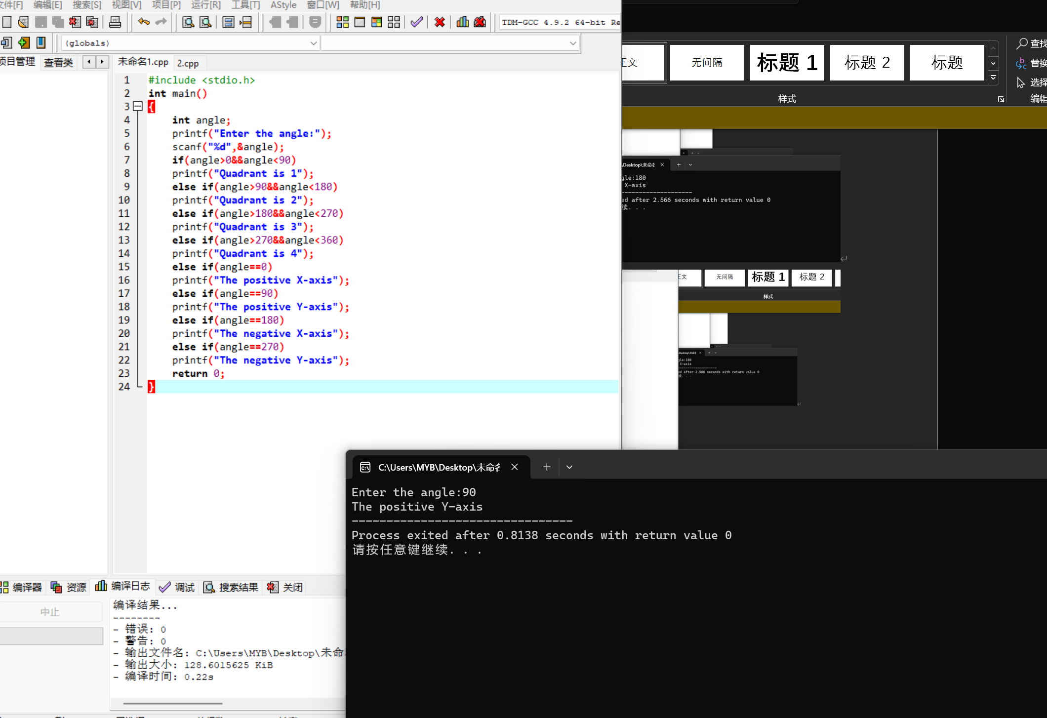

140.3

#include <stdio.h>

int main()

{

int year;

printf("Enter the year:");

scanf("%d",&year);

if(year%400==0)

printf("The year is leap year!");

else if(year%4==0&&year%100!=0)

printf("The year is leap year!");

else

printf("The year is not leap year!");

return 0;

}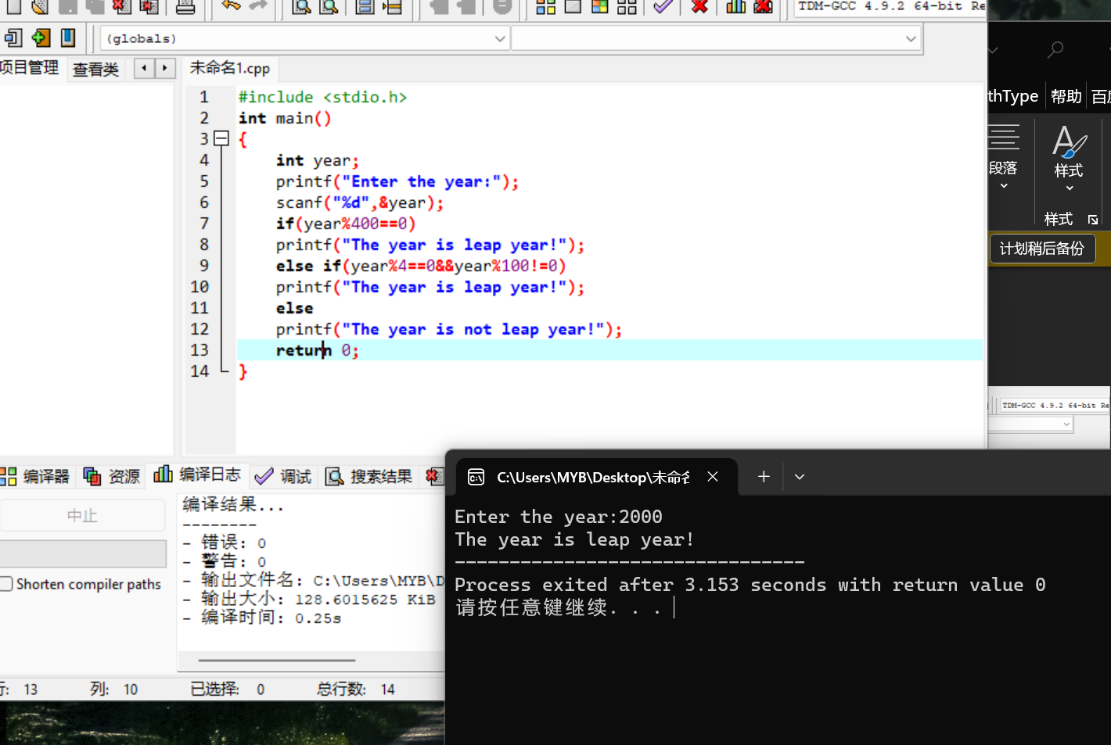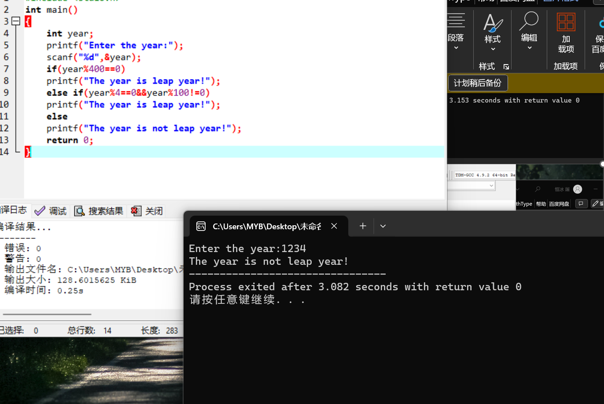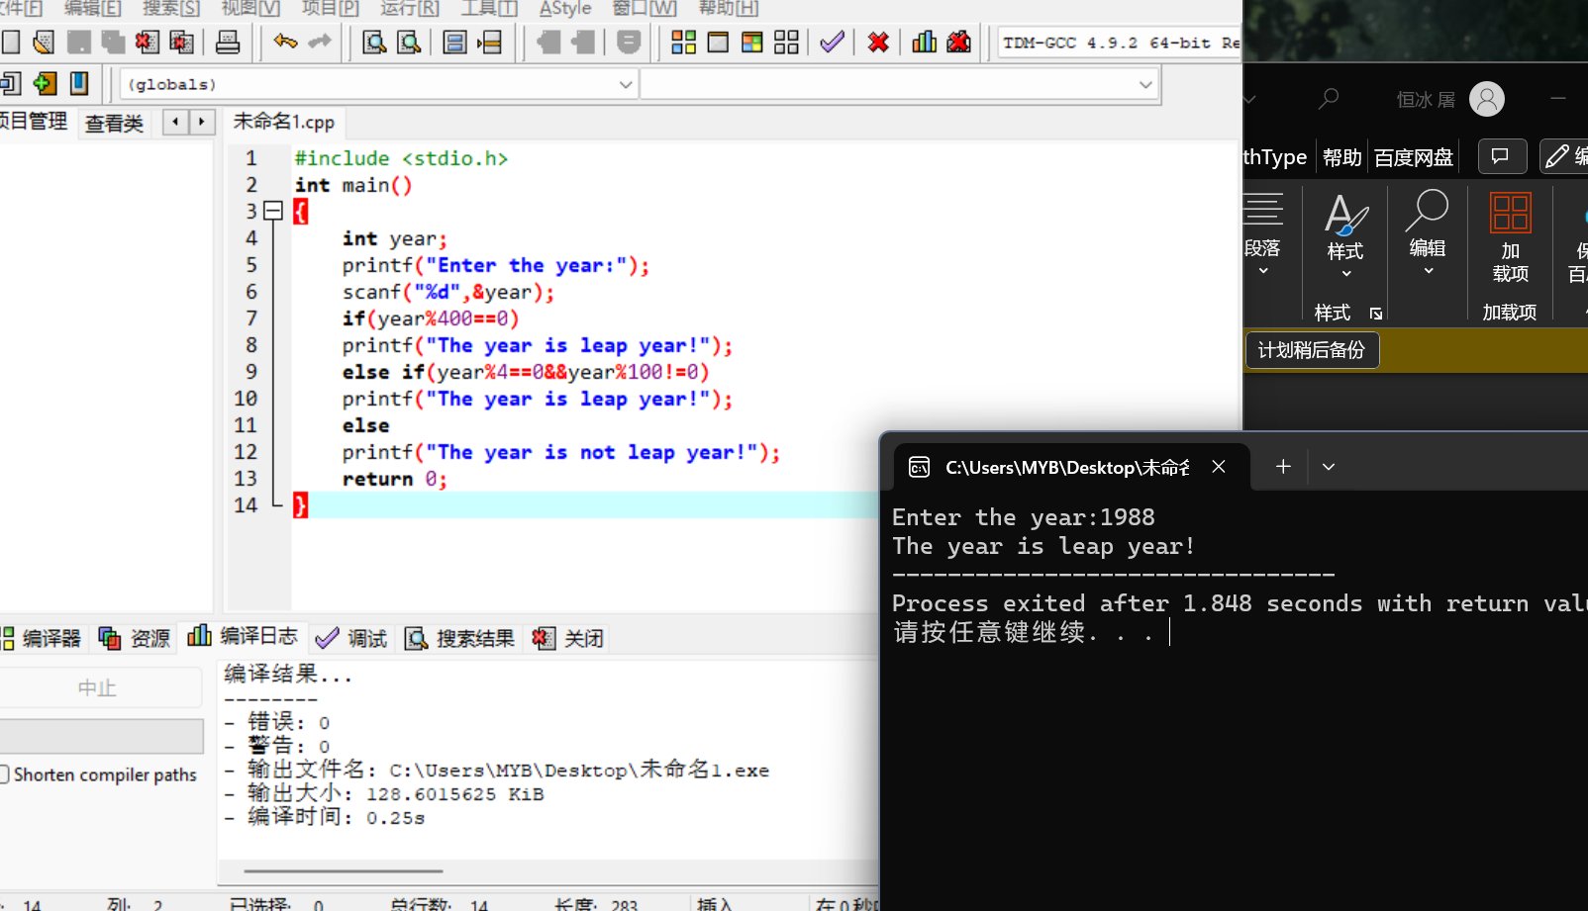

b.

#include <stdio.h>

int main()

{

int month,day;

int year;

printf("Enter the year:");

scanf("%d",&year);

printf("Enter a month (use a 1 for Jan,etc.)");

scanf("%d",&month);

printf("Enter a day of the month:");

scanf("%d",&day);

if(month<1||month>12)

printf("\nMonth is invalid");

if((year%400==0)||(year%4==0&&year%100!=0))

switch(month)

{

case 1:case 3:case 5:case 7:case 8:case 10:case 12:

if(day>31||day<1)

printf("\nThe day is invalid in the month");

break;

case 2:

if((year%400==0)||(year%4==0&&year%100!=0))

{if(day>29||day<1)

printf("\nThe day is invalid in the month");}

else

if(day>28||day<1)

printf("\nThe day is invalid in the month");

break;

case 4:case 6:case 9:case 11:

if(day>30||day<1)

printf("\nThe day is invalid in the month");

break;

}

return 0;

}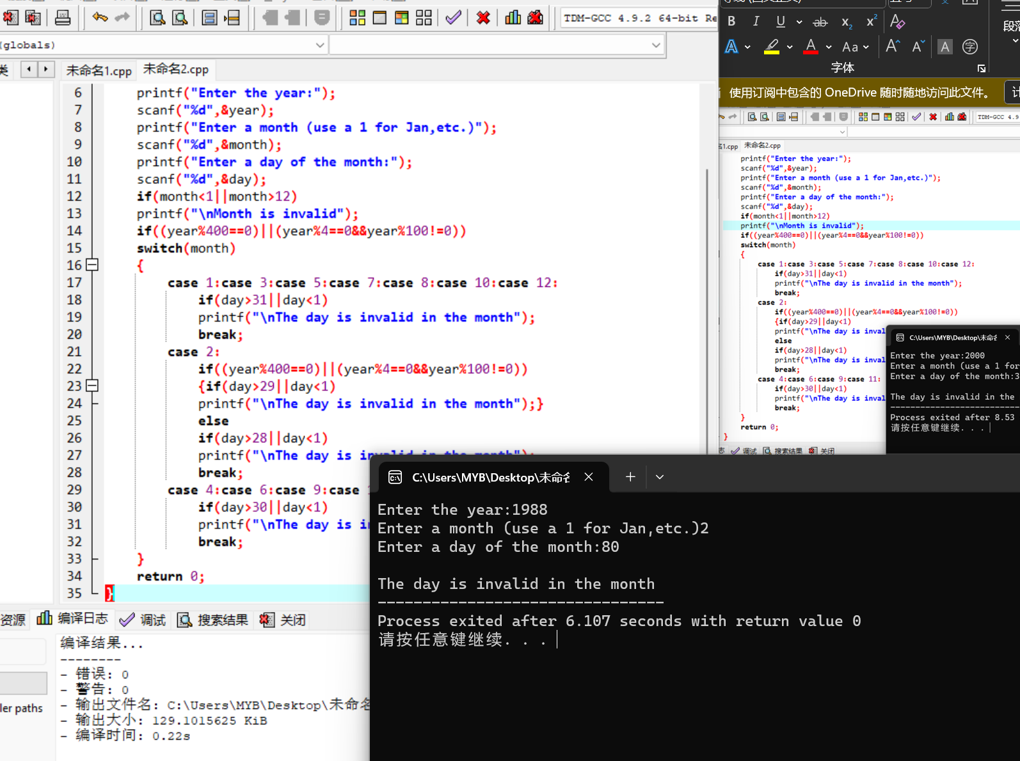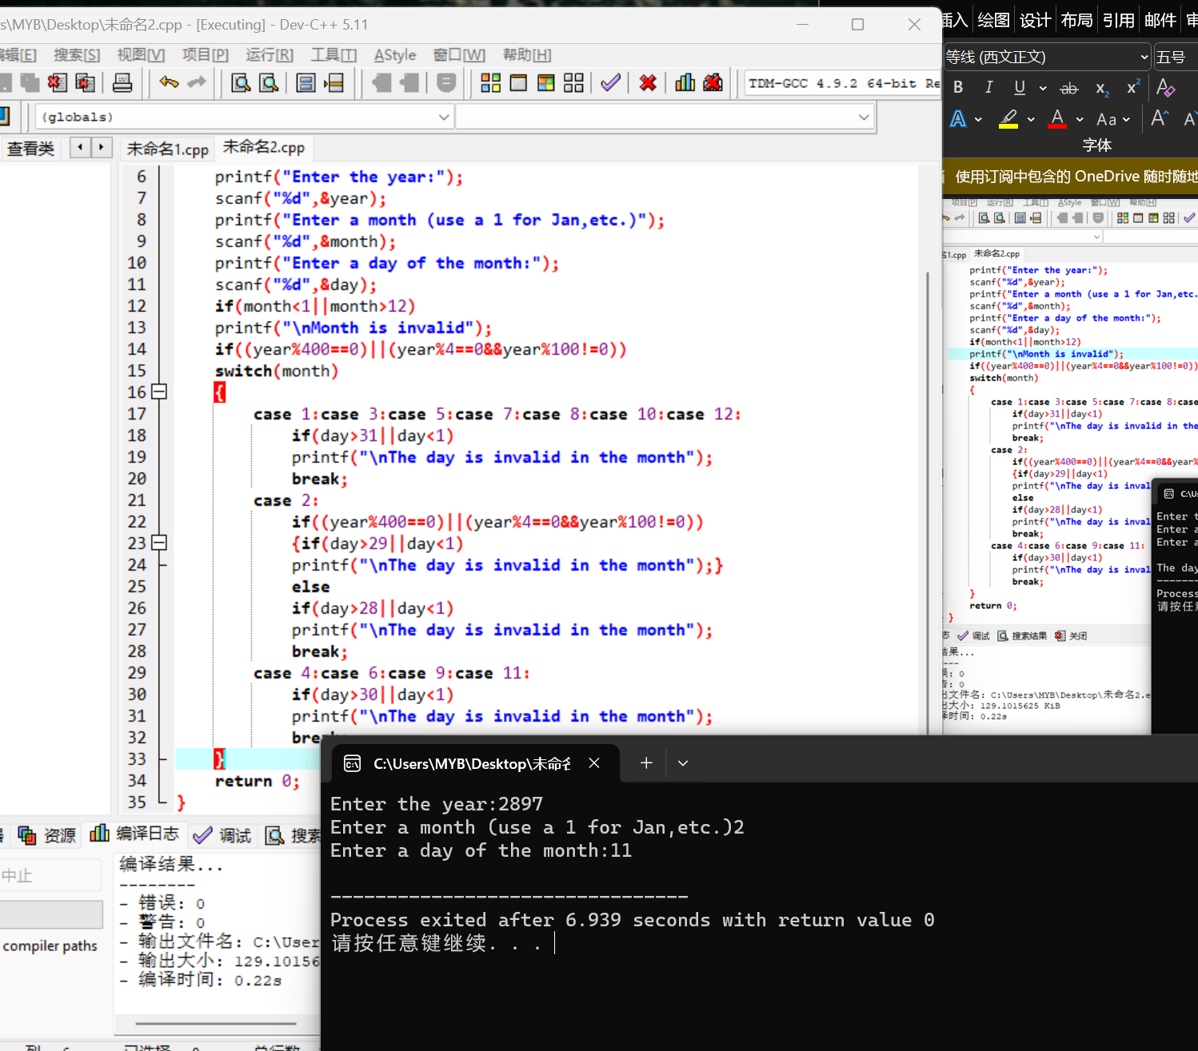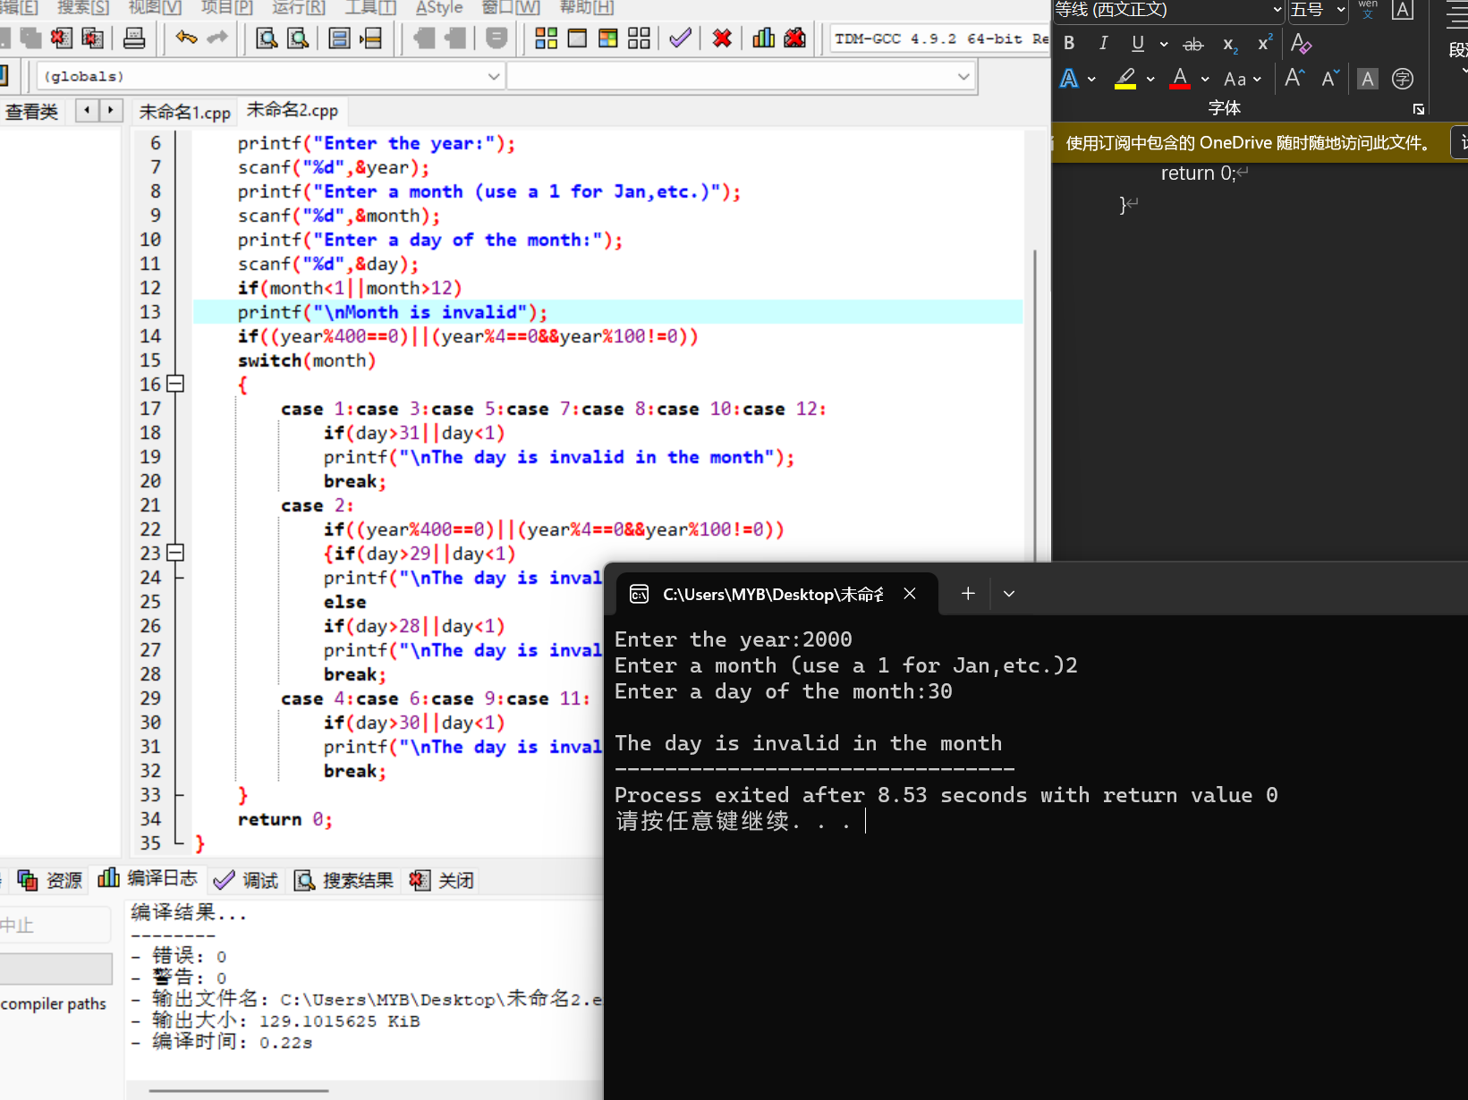

141.5

#include <stdio.h>

#include <math.h>

int main()

{

float a,b,c,rootOne,rootTwo;

printf("Enter a,b,c:");

scanf("%f %f %f",&a,&b,&c);

if(a==0)

printf("a is invalid!");

else

{

if(b\*b-4\*a\*c<0)

printf("The equation has no root!");

else

{rootOne=(-b+sqrt(b\*b-4\*a\*c))/(2.0\*a);

rootTwo=(-b-sqrt(b\*b-4\*a\*c))/(2.0\*a);

printf("rootOne=%.3lf\n\nand:\n\nrootTwo=%.3lf\n",rootOne,rootTwo);}

}

return 0;

}